Tutorial: Working with Tableau

Tingying He, Feb 2024

**Acknowledgment:** This tutorial is based on:

* [Tableau Help](https://www.tableau.com/support/help?_gl=1*1ssjx00*_ga*MjAyNjYwOTY2Ny4xNzA1MzM3MzM1*_ga_8YLN0SNXVS*MTcwNjg4OTIxMi4yMi4xLjE3MDY4ODkzMTAuMC4wLjA.&_ga=2.139676534.414756814.1706800844-2026609667.1705337335), particularly the [Tutorial: Get Started with Tableau Desktop](https://help.tableau.com/current/guides/get-started-tutorial/en-us/get-started-tutorial-home.htm).
* Tableau tutorial class demo of this class last year by Jiayi Hong ( [Demo](https://www.youtube.com/watch?v=Ysay_I_5ng8), [Raw file](https://drive.google.com/file/d/10HKa-LMt7937_jInm1Le7NFP6SEdplgu/view) ).

**Before the tutorial:**

Install Tableau. You can request a free license as a student [here](https://www.tableau.com/academic/students). Please note that it can take 1–2 days for Tableau Inc. to validate your student status and thus send you your license key. So start this process well ahead of the tutorial day.

**Getting Started:**

Download the datasets: [Data in CSV format](https://drive.google.com/file/d/1kANycs-0wDYGTOyBUWJjas7FT_h8sCxC/view).

For French or other non-English computers, you may need to download the data in the [TSV format](https://drive.google.com/file/d/1k1hcYaBstj6mgbfCXSChI6uZgdOeQOl1/view) for Tableau to import the data correctly. Based on this, you could check the data types when loading the data.

You can also try the [Excel](https://docs.google.com/spreadsheets/d/1efIIL8L9yGGgNxbN8zhN_5njDK4tEGIS/edit?usp=sharing&ouid=101991385567187332416&rtpof=true&sd=true) format.

# What is Tableau?

* Tableau is a powerful and widely used data visualization software.
* Official website: <https://www.tableau.com/en-gb>
* Tableau offers a range of [products](https://www.tableau.com/en-gb/products). We use Tableau Desktop in this tutorial.

# Dataset for this tutorial

* The dataset we use is from the [World Justice Project](https://worldjusticeproject.org/rule-of-law-index/?gclid=Cj0KCQiAwvKtBhDrARIsAJj-kTjh4p7F9P-i93B4p2xNtaK2QxKuys8ESgjOz6L77-L_MQSpwkow5o4aAou7EALw_wcB), an international civil society organization with the stated mission of "working to advance the rule of law around the world."
* The dataset is the Rule of Law Index, which assesses the rule of law in each country based on multiple factors. To know more information about each factor, see [here](https://worldjusticeproject.org/our-work/research-and-data/factors-rule-law#:~:text=Factor%201%3A%20Constraints%20on%20Government%20Powers,-Constraints%20on%20Governments&text=It%20comprises%20the%20means%2C%20both,held%20accountable%20under%20the%20law.).

# Today's plan

We will explore the data, focusing mainly on Factor 1 (Constraints on Government Powers) and Factor 2. (Absence of Corruption), and get familiar with Tableau. We will:

1. Load and prepare the data
2. Drag and drop to take a first look
   * What is Factor 1 for each country? → **Bar chart**
3. Explore the data geographically
   * How are the values of Factor 1 distributed across the world? → **Map**
4. Explore the relationship between two dimensions
   * How does Factor 1 relate to Factor 2 across different countries? → **Scatter Plot + Trend Line**
   * Which countries have high values in both Factor 1 and Factor 2? → **Scatter Plot + Average values**
5. Add a filter to the view
   * Which countries exceed a specific threshold for Factor 1? → **Filter**
6. Show the insights **→ Dashboard**

# Tutorial

## 1. Connect to the data

### Start page

The start page is the first page we see after launching Tableau. It includes the following parts:

* Tableau icon
* Connect pane
* Accelerators: samples
* Open: recent workbooks
* Discover: additional sources.

To know more about it, see [here](https://help.tableau.com/current/pro/desktop/en-us/environment_startpage.htm).

### Load data

To import data into Tableau:

1. Click on "More" in the left sidebar, then navigate to the location of the data file.
2. Select the data file and open it. If prompted, we need to allow Tableau to access files in our folder.
3. After loading the data, we will be able to view it in Tableau.

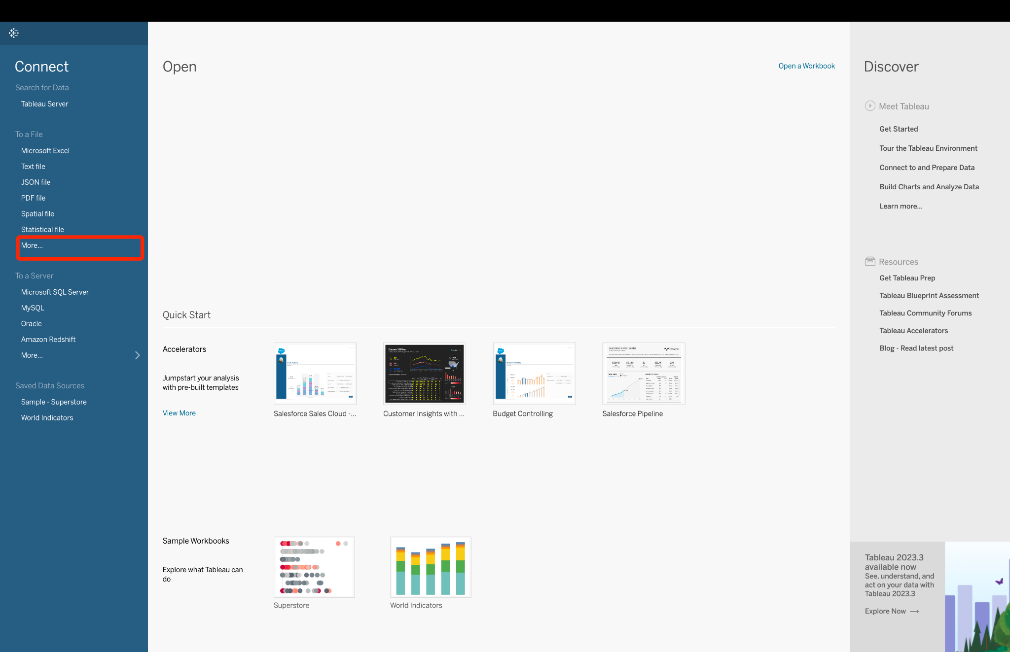

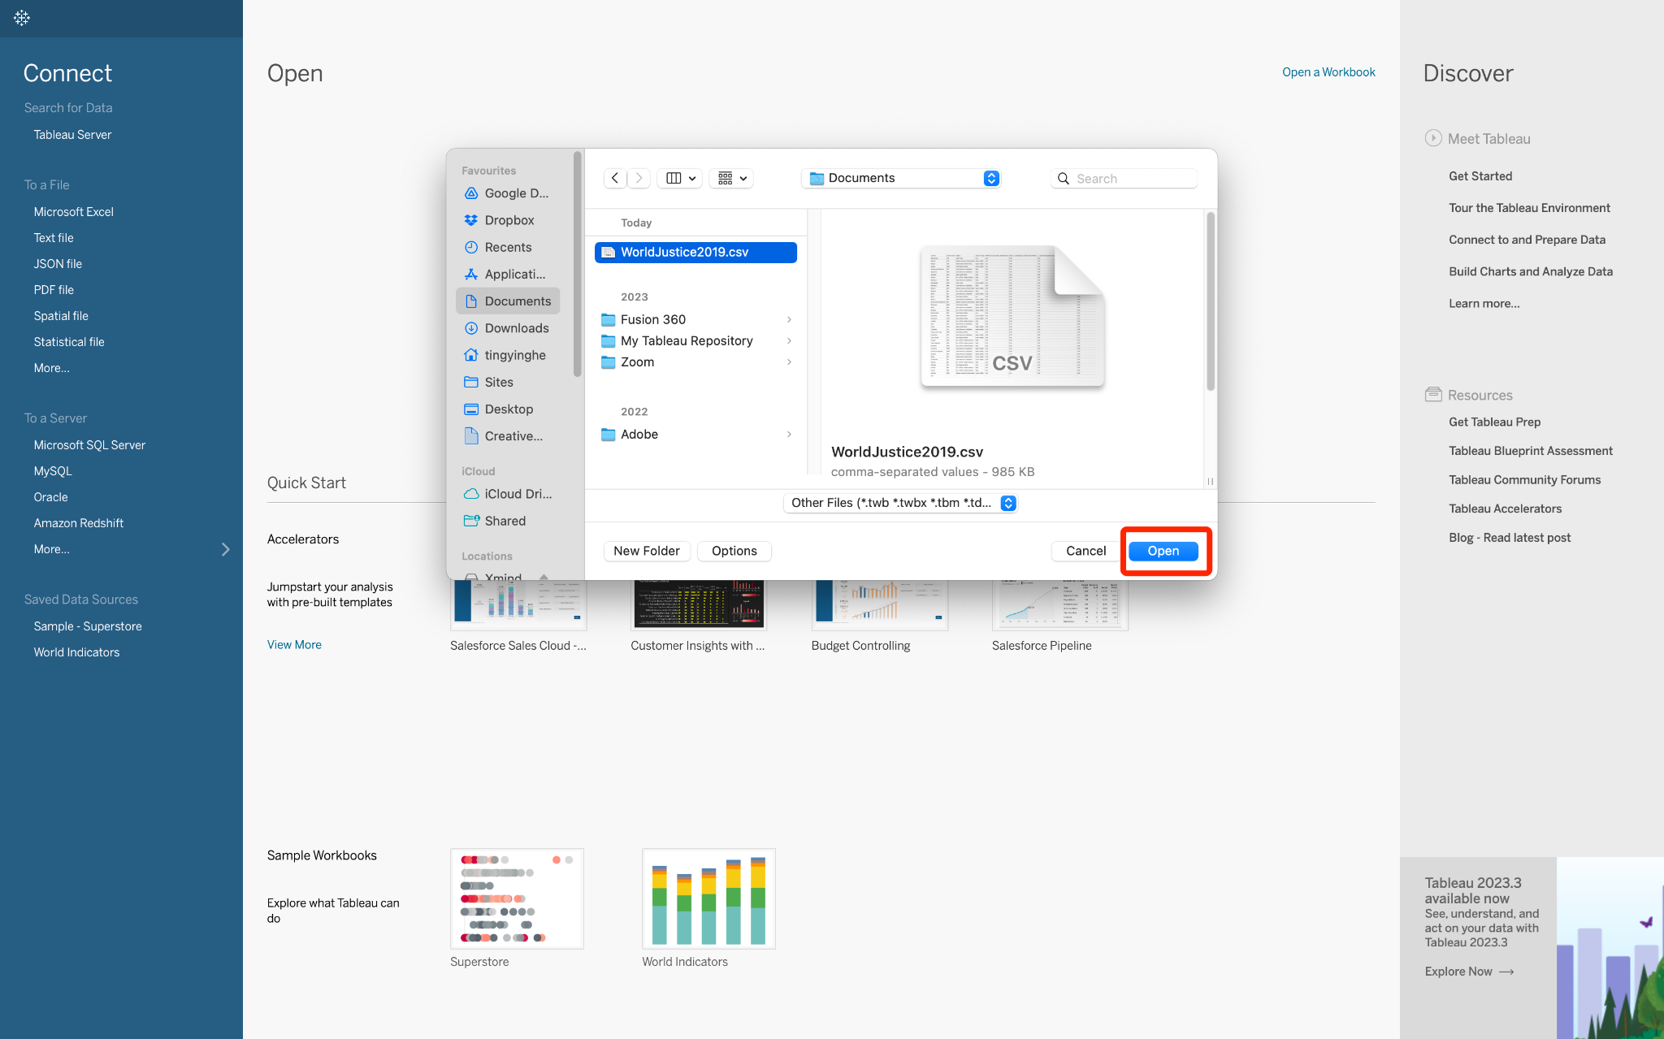

### Data source page

We can inspect and explore the data source on the data source page. The "Fields" are the column names in the dataset. To learn more about the data source page, click [here](https://help.tableau.com/current/pro/desktop/en-us/environment_datasource_page.htm).

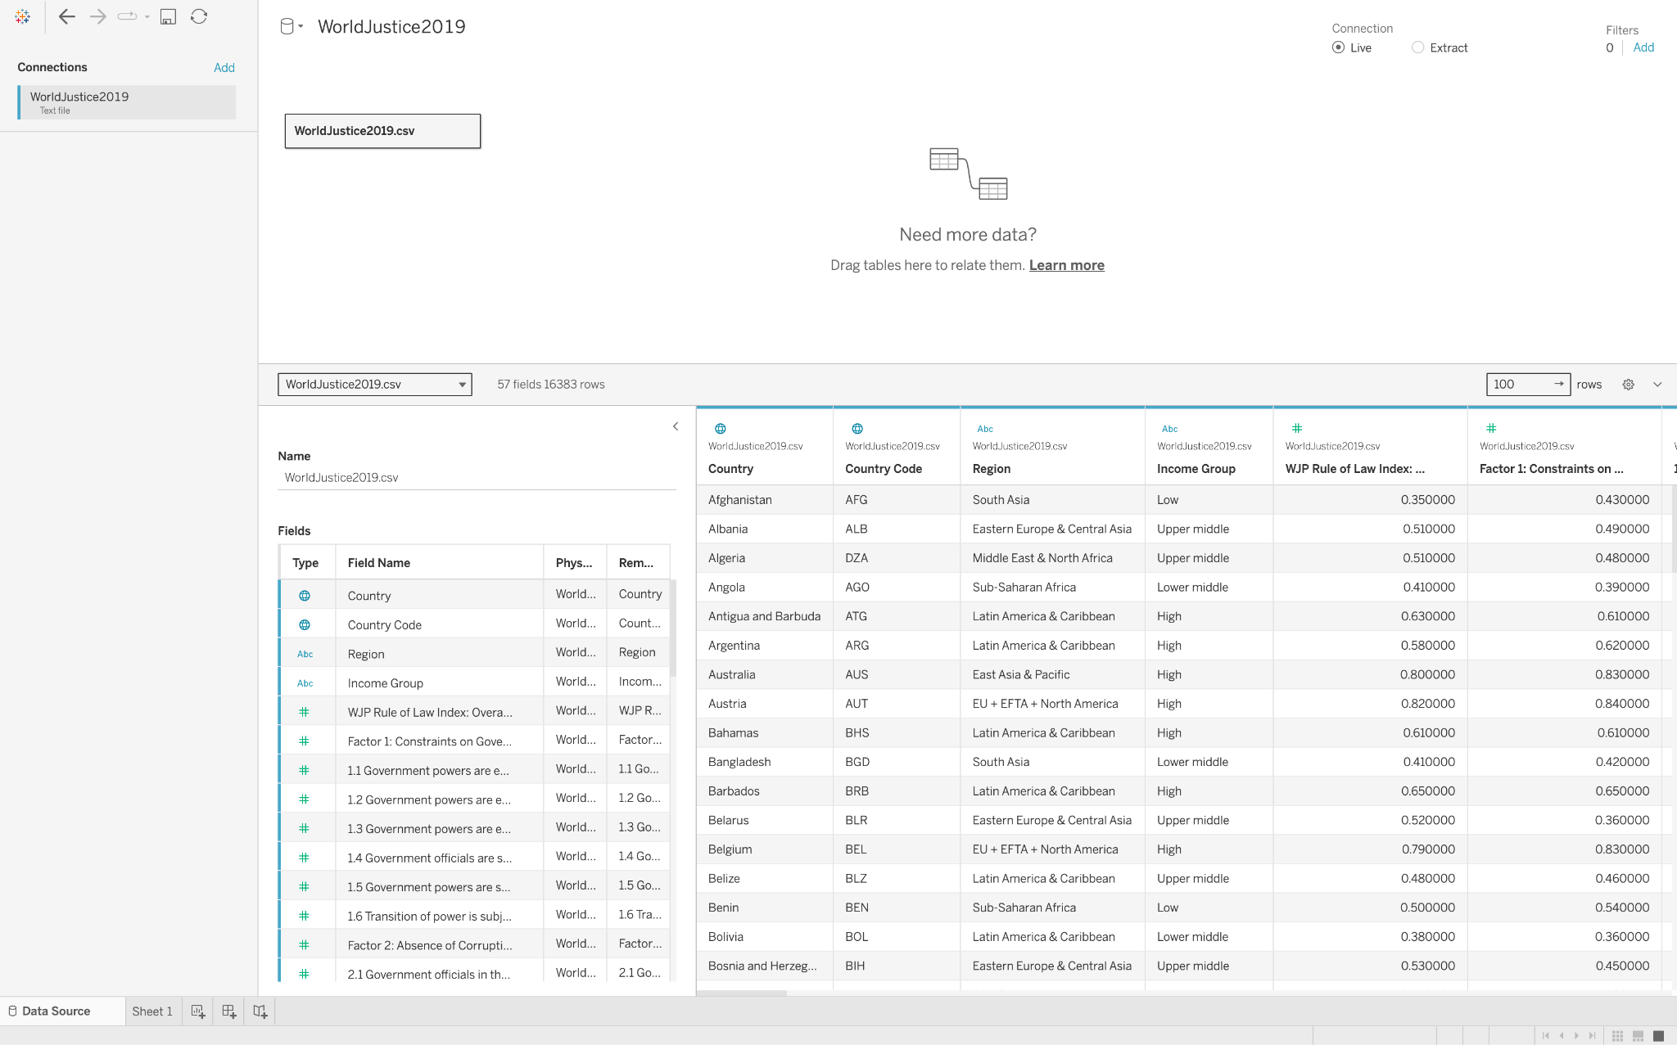

### Select data to edit

To select data:

1. Select a row in "Fields" by left-clicking on it. After clicking, the row will have a light blue background, indicating it is selected.
2. Select multiple rows at the same time: After selecting one row, hold down the Shift key and click on another row. This action will select all rows between these two.

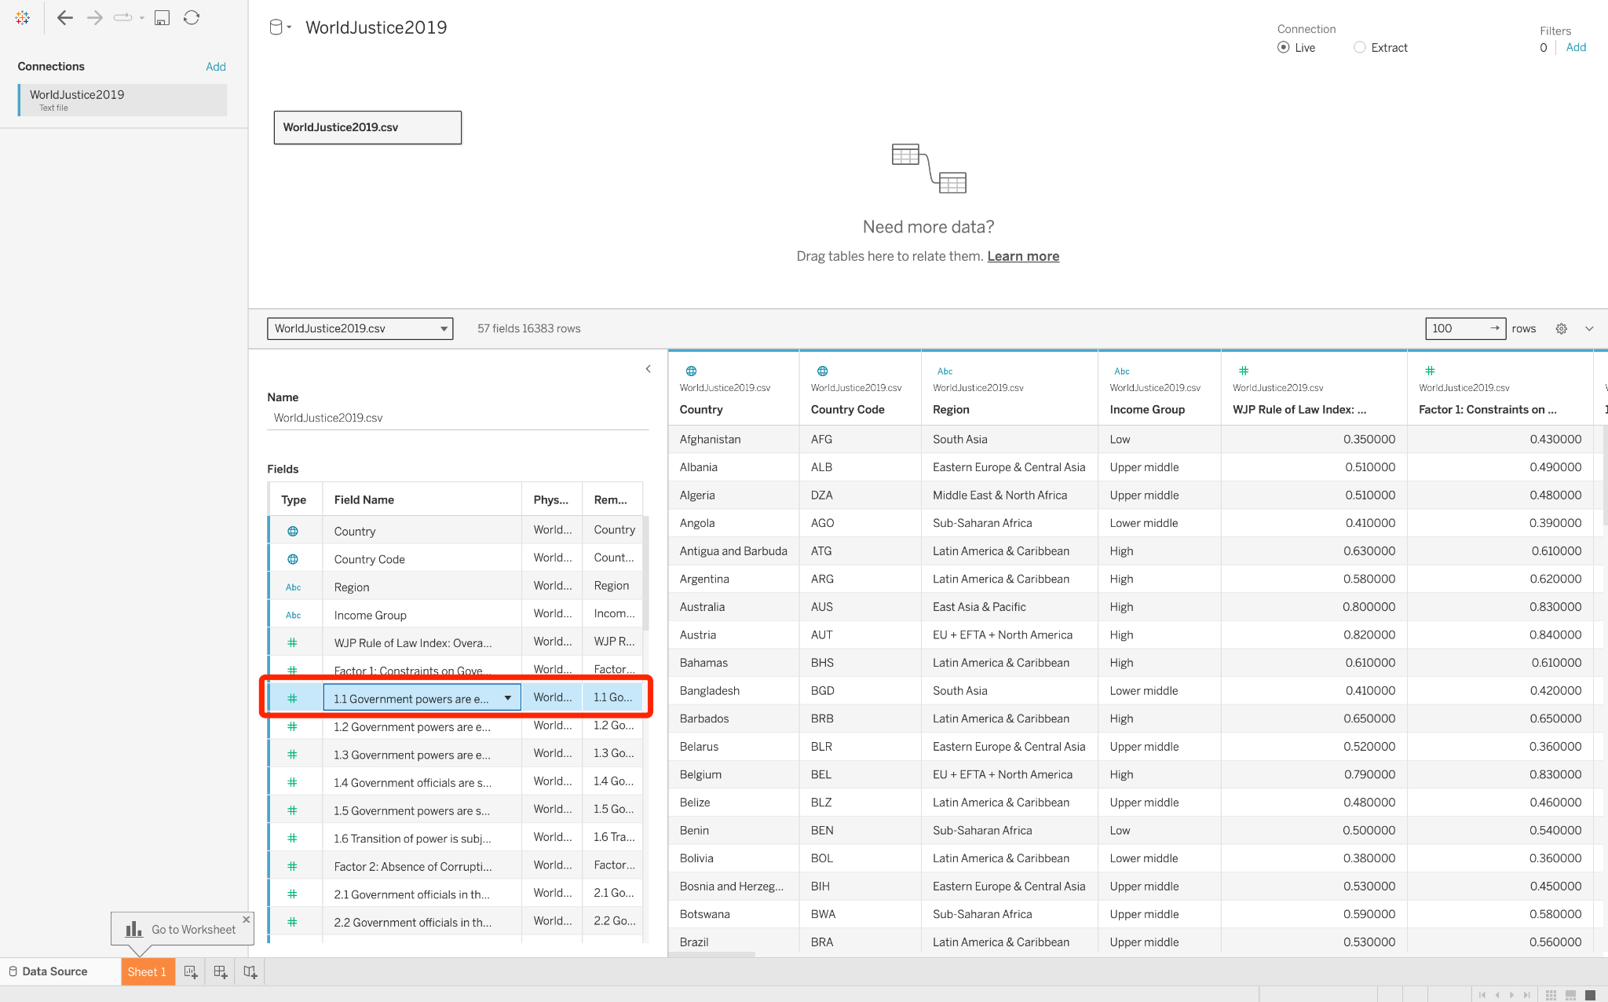

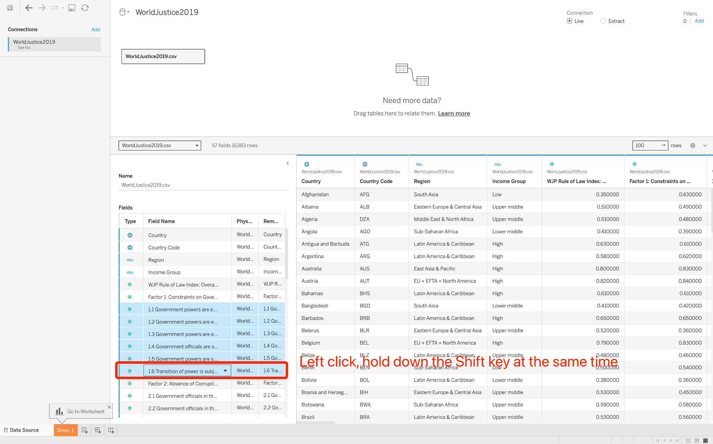

### Hide unnecessary fields

In this tutorial, we will not delve into the sub-factors within the dataset, such as 1.1, 1.2, 1.3, and so on. So, we hide all of these sub-factors.

To hide unnecessary fields:

1. Right-click on the selected data, and a pop-up window will appear.
2. Click "Hide" in the pop-up window.

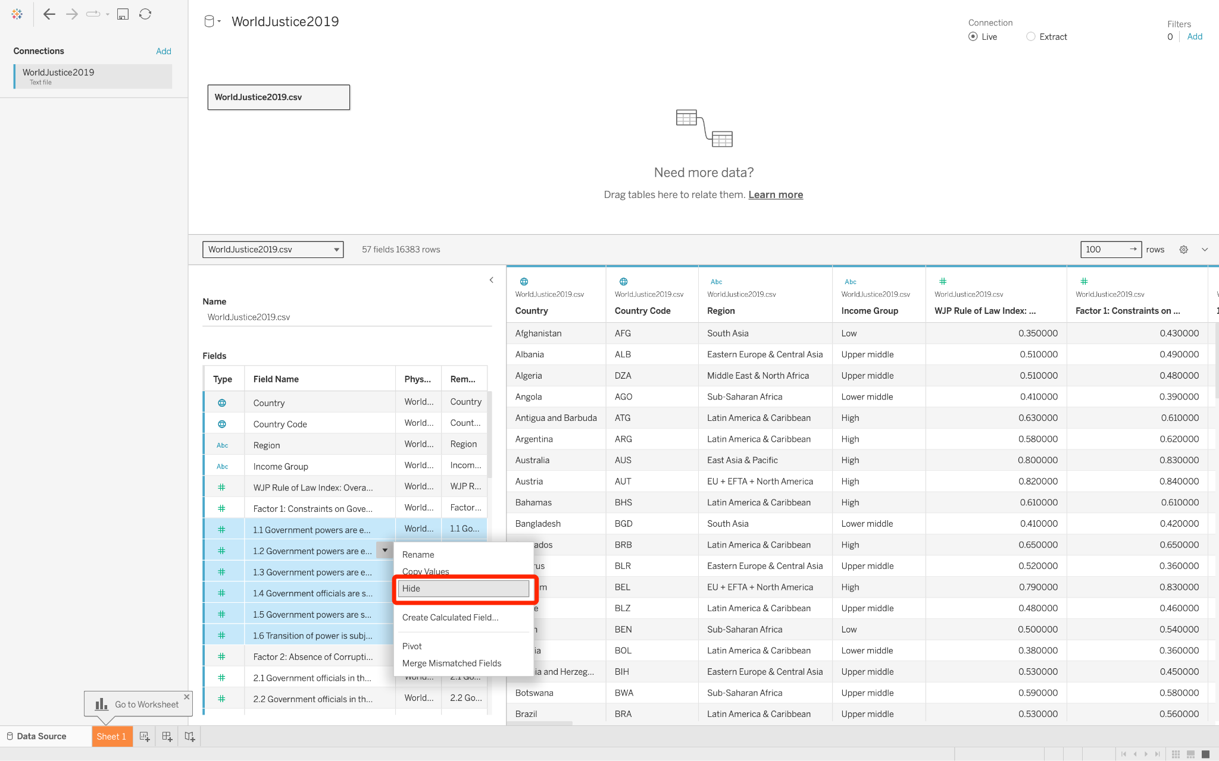

## 2. Drag and drop to take a first look [Bar chart]

Question to explore:

* What is Factor 1 for each country? → Bar chart

### Tableau workspace

We can create a new blank worksheet by clicking the '+' on the sheet tab at the bottom of the page. However, Tableau has already provided 'Sheet 1' for us. Click 'Sheet 1' to enter the Tableau workspace.

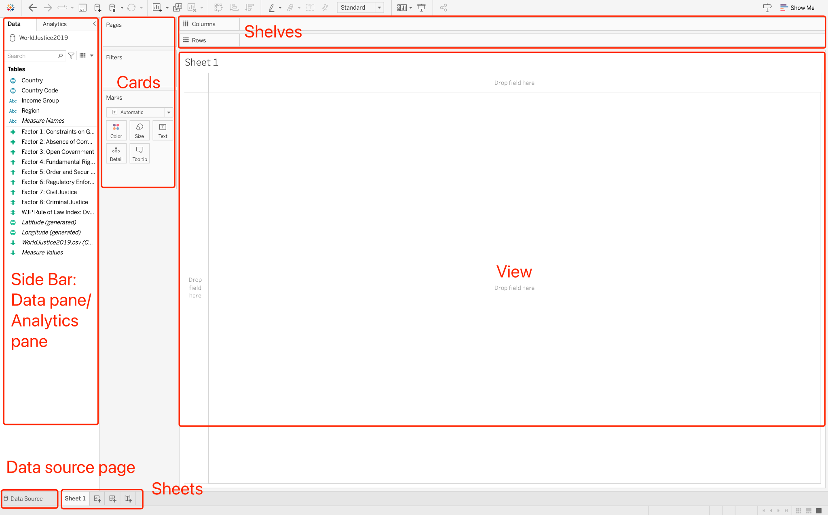

* SideBar - In a worksheet, the sidebar area contains Data and Analytics panes.
  + The color of fields in the Tables: blue (discrete data) or green (continuous data)
* Cards and shelves - Drag fields to the cards and shelves in the workspace to add data to your view.
* View - This is the canvas in the workspace where you create a visualization.
* Data source page - Click this tab to go to the Data Source page and view your data.
* Sheet tabs - Tabs represent each sheet in your workbook.

To learn more about the Tableau workspace, click [here](https://help.tableau.com/current/pro/desktop/en-us/environment_workspace.htm).

### Columns and Rows

To visualize each country's Constraints on Government Powers (Factor 1), we can:

1. Drag the field "Factor 1: Constraints on Government Powers" to the "Rows" shelf. Simply click on the field, drag it, and then drop it onto the "Rows" shelf.
2. Drag the "Country" field to the "Columns" shelf.

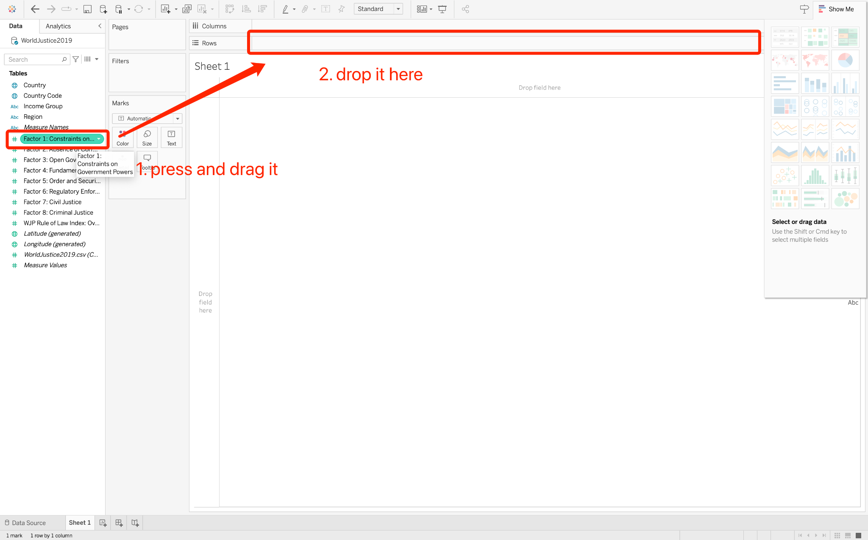

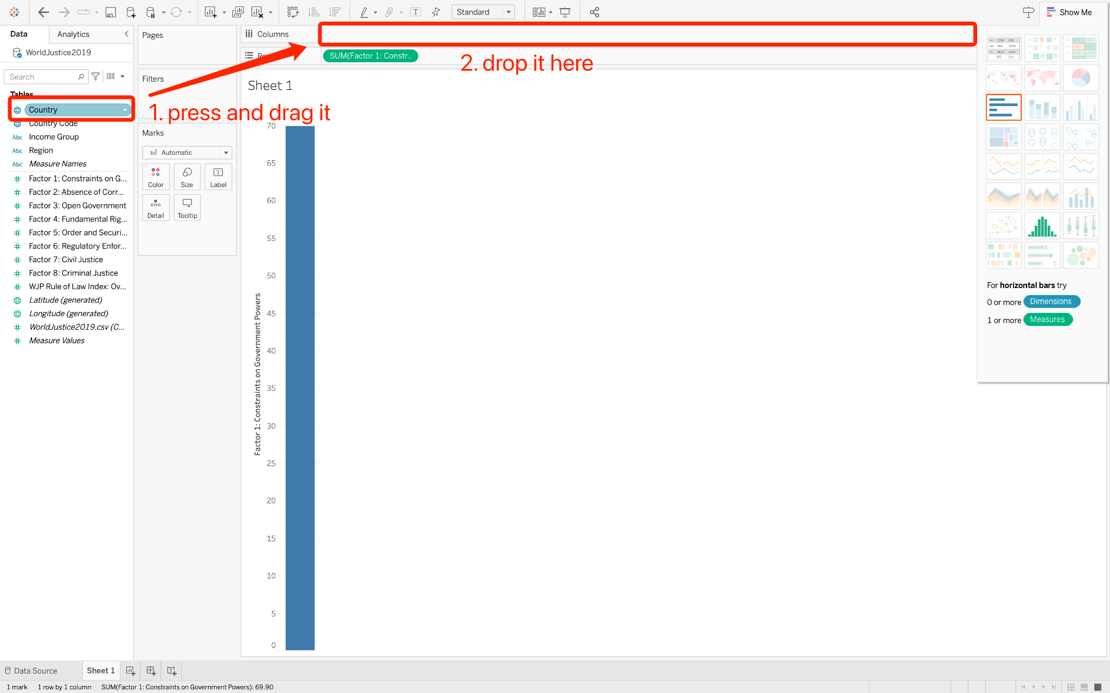

### Exclude unwanted bar

Here, we see a "Null" bar in the bar chart. Click on it and choose "Exclude" in the pop-up window to remove it.

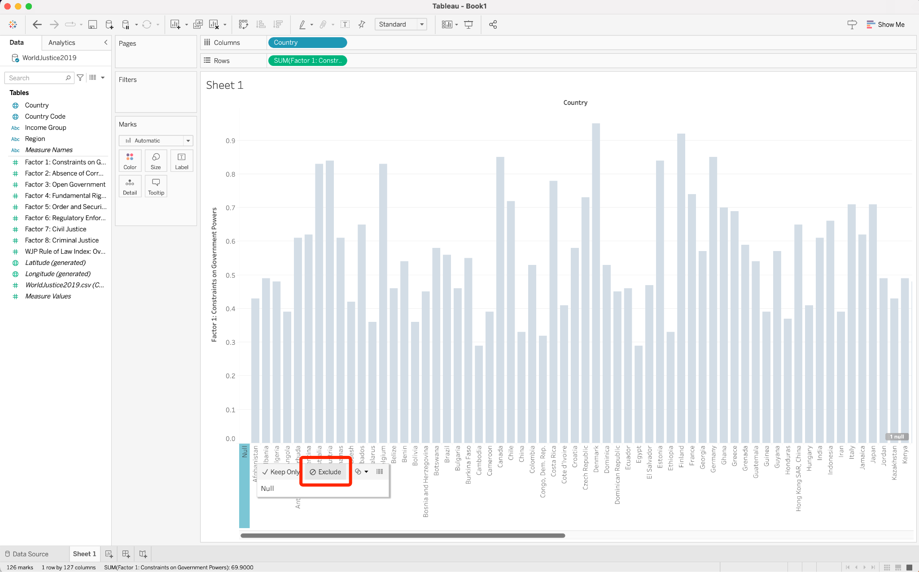

## 3. Explore the data geographically [Map]

Question to explore:

* How are values of Factor 1 distributed across the world? → Map

### Change chart type with "Show Me"

At the top left of the workspace, there is a "Show Me" button. Clicking on it will open or close the Show Me pane. This pane suggests chart types based on the fields already used in the view and any fields we have selected in the Data pane.

Click on the Map option in the Show Me pane.

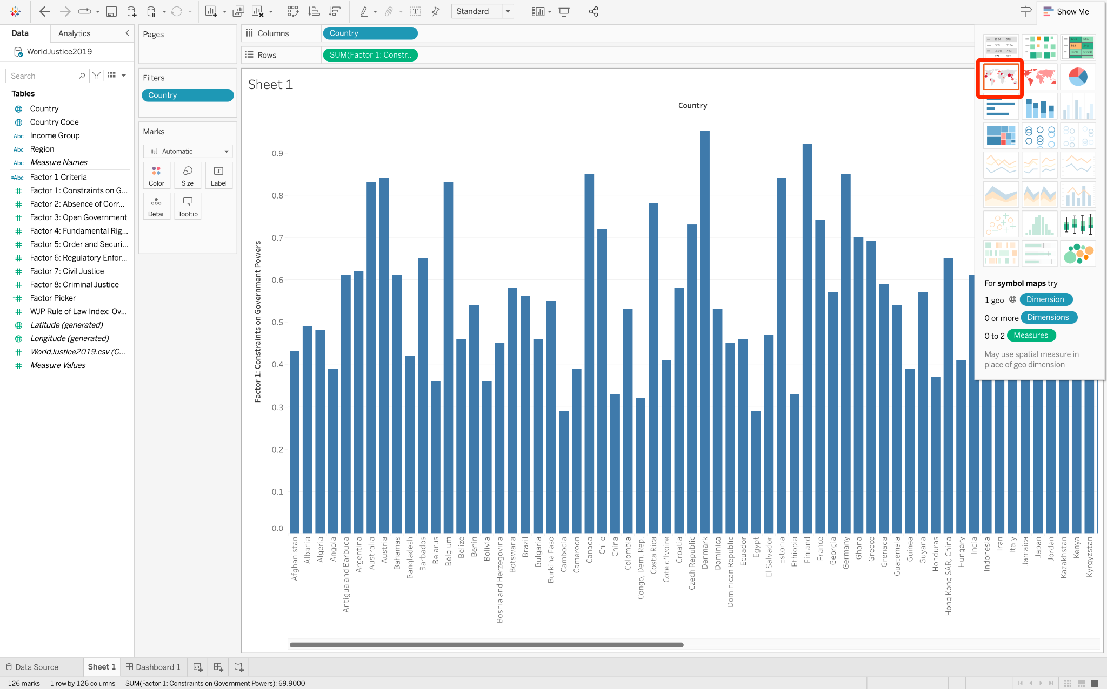

### Change the sheet's name and chart name

1. Double-click on the sheet tab to rename it "World Map for Factor1".
2. We can double-click the chart name on the view and also change it to "World Map for Factor1".

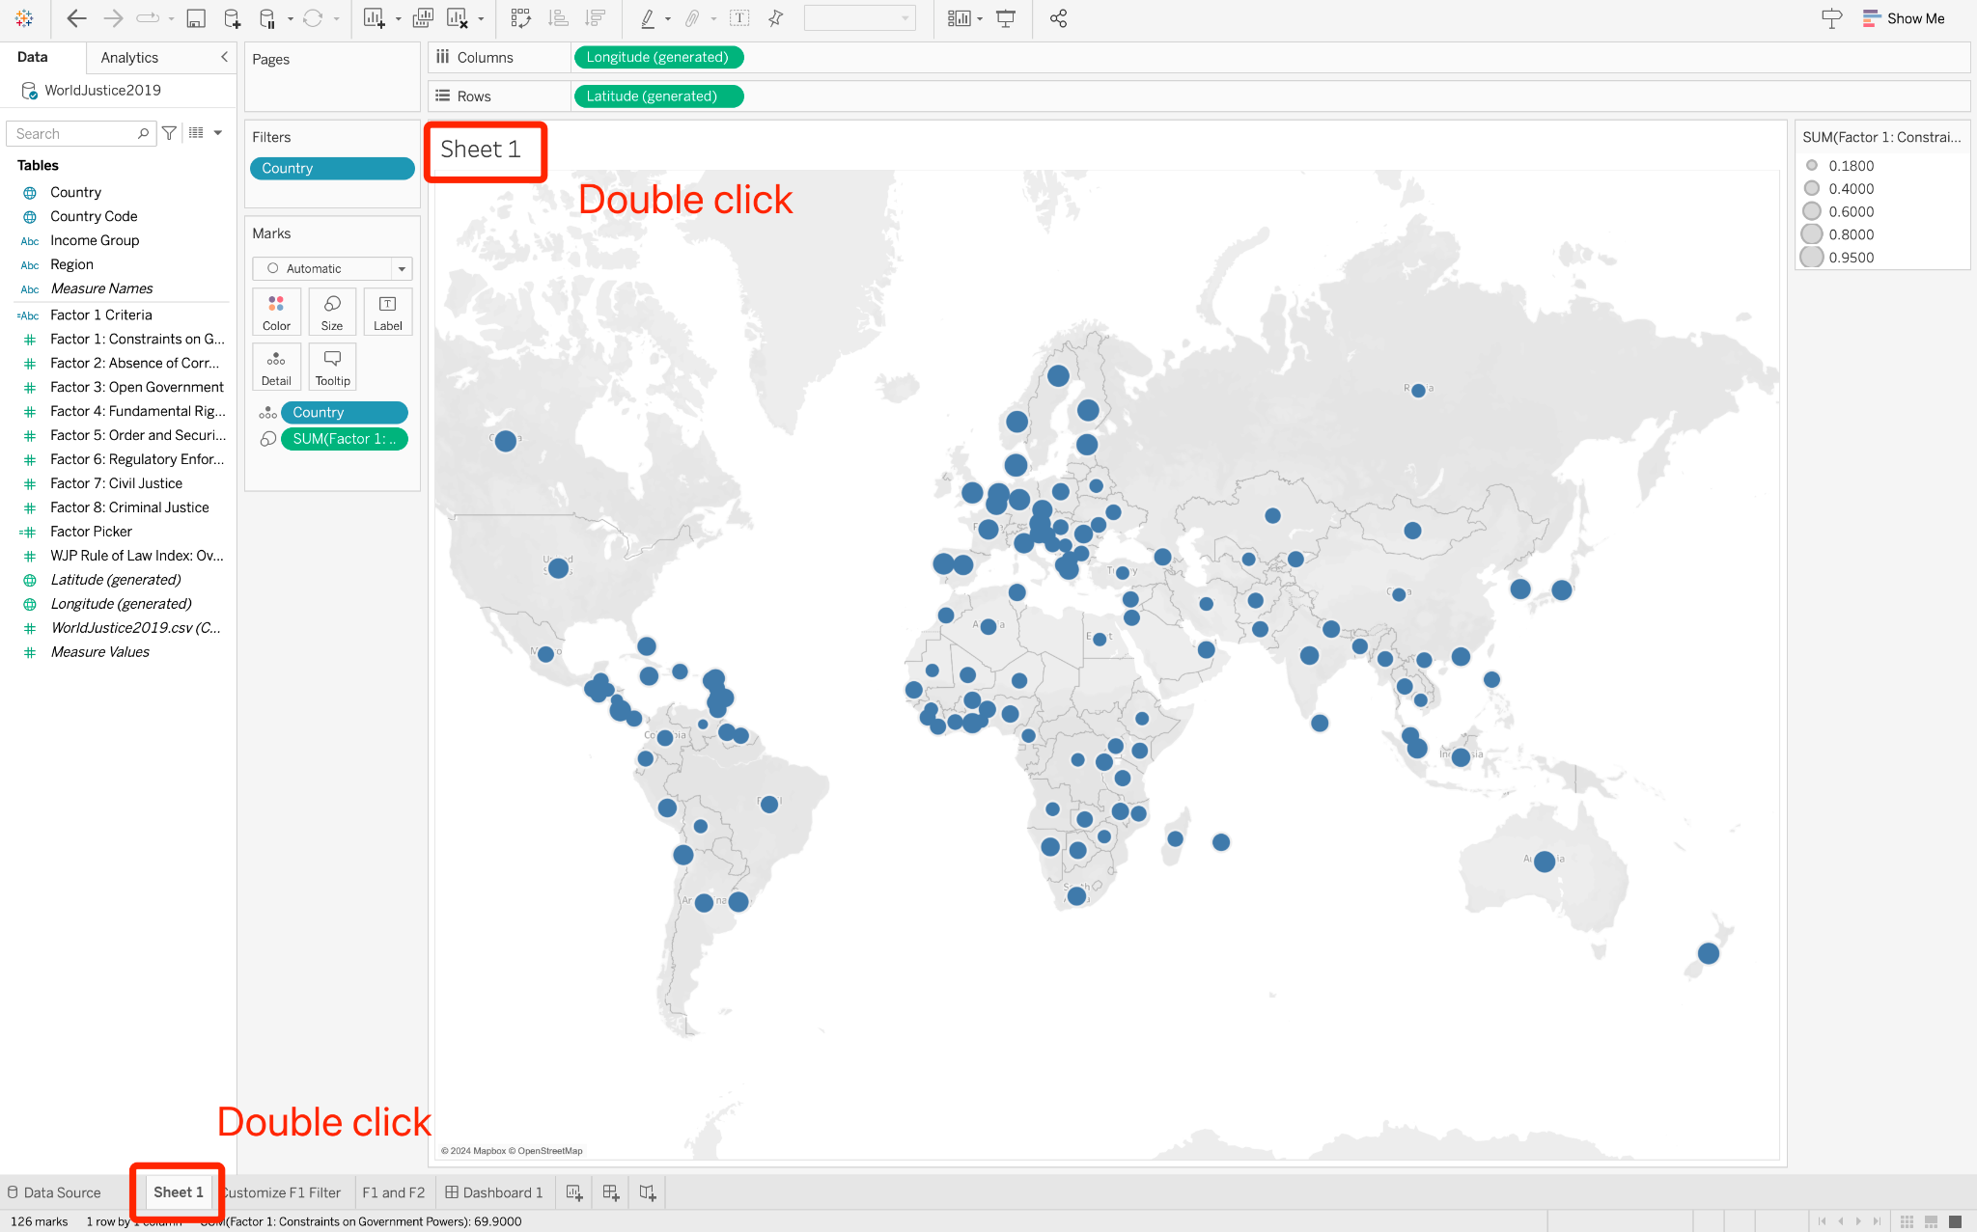

## 4. Explore the relationship between two dimensions [Scatter plot]

Questions to explore:

* How does Factor 1 relate to Factor 2 across different countries? → **Scatter Plot + Trend Line**
* Which countries have high values in both Factor 1 and Factor 2? → **Scatter Plot + Average values**

### Create the Scatter plot

We will position Factor 1 on the y-axis and Factor 2 on the x-axis, with the countries represented as scattered dots:

1. drag Factor 1 to the Rows shelf and Factor 2 to the Columns shelf.
2. drag the Country field and drop it onto the View

### Show trend line

Click on the "Analytics" tab in the sidebar to view the analytics options available in Tableau.

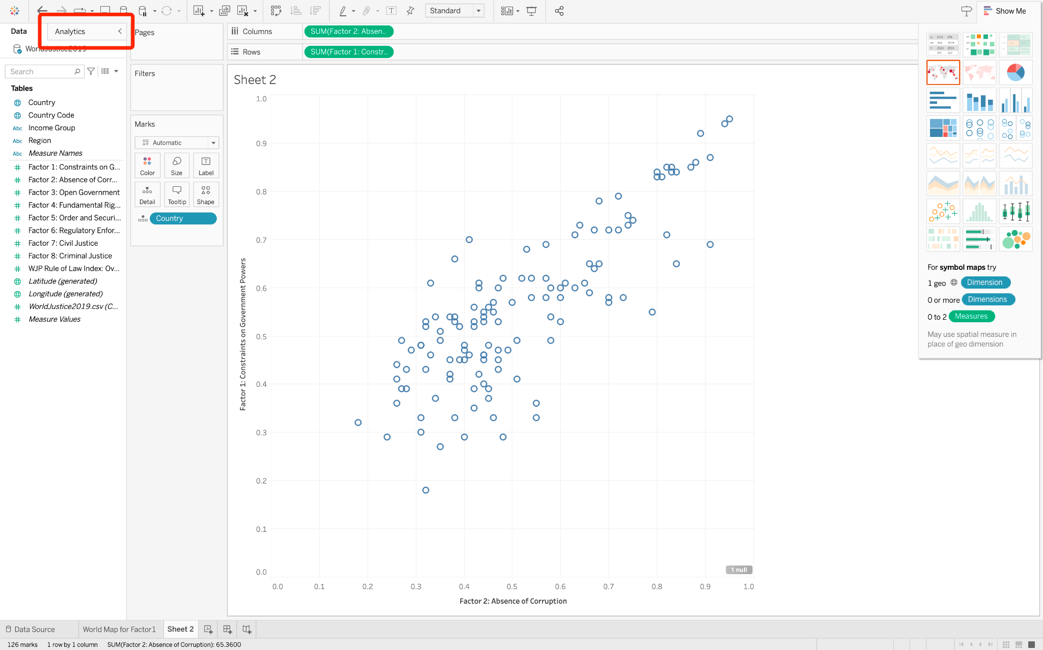

We want to observe a trend in the scatter plot:

1. Drag the "Trend Line" option from the Analytics pane
2. A floating window will appear, offering several types of trend lines.
3. Since we want a linear trend line, drop the "Trend Line" we are dragging onto "Linear."
4. We can see the trend line and know that Factor 1 and Factor 2 are positively related.

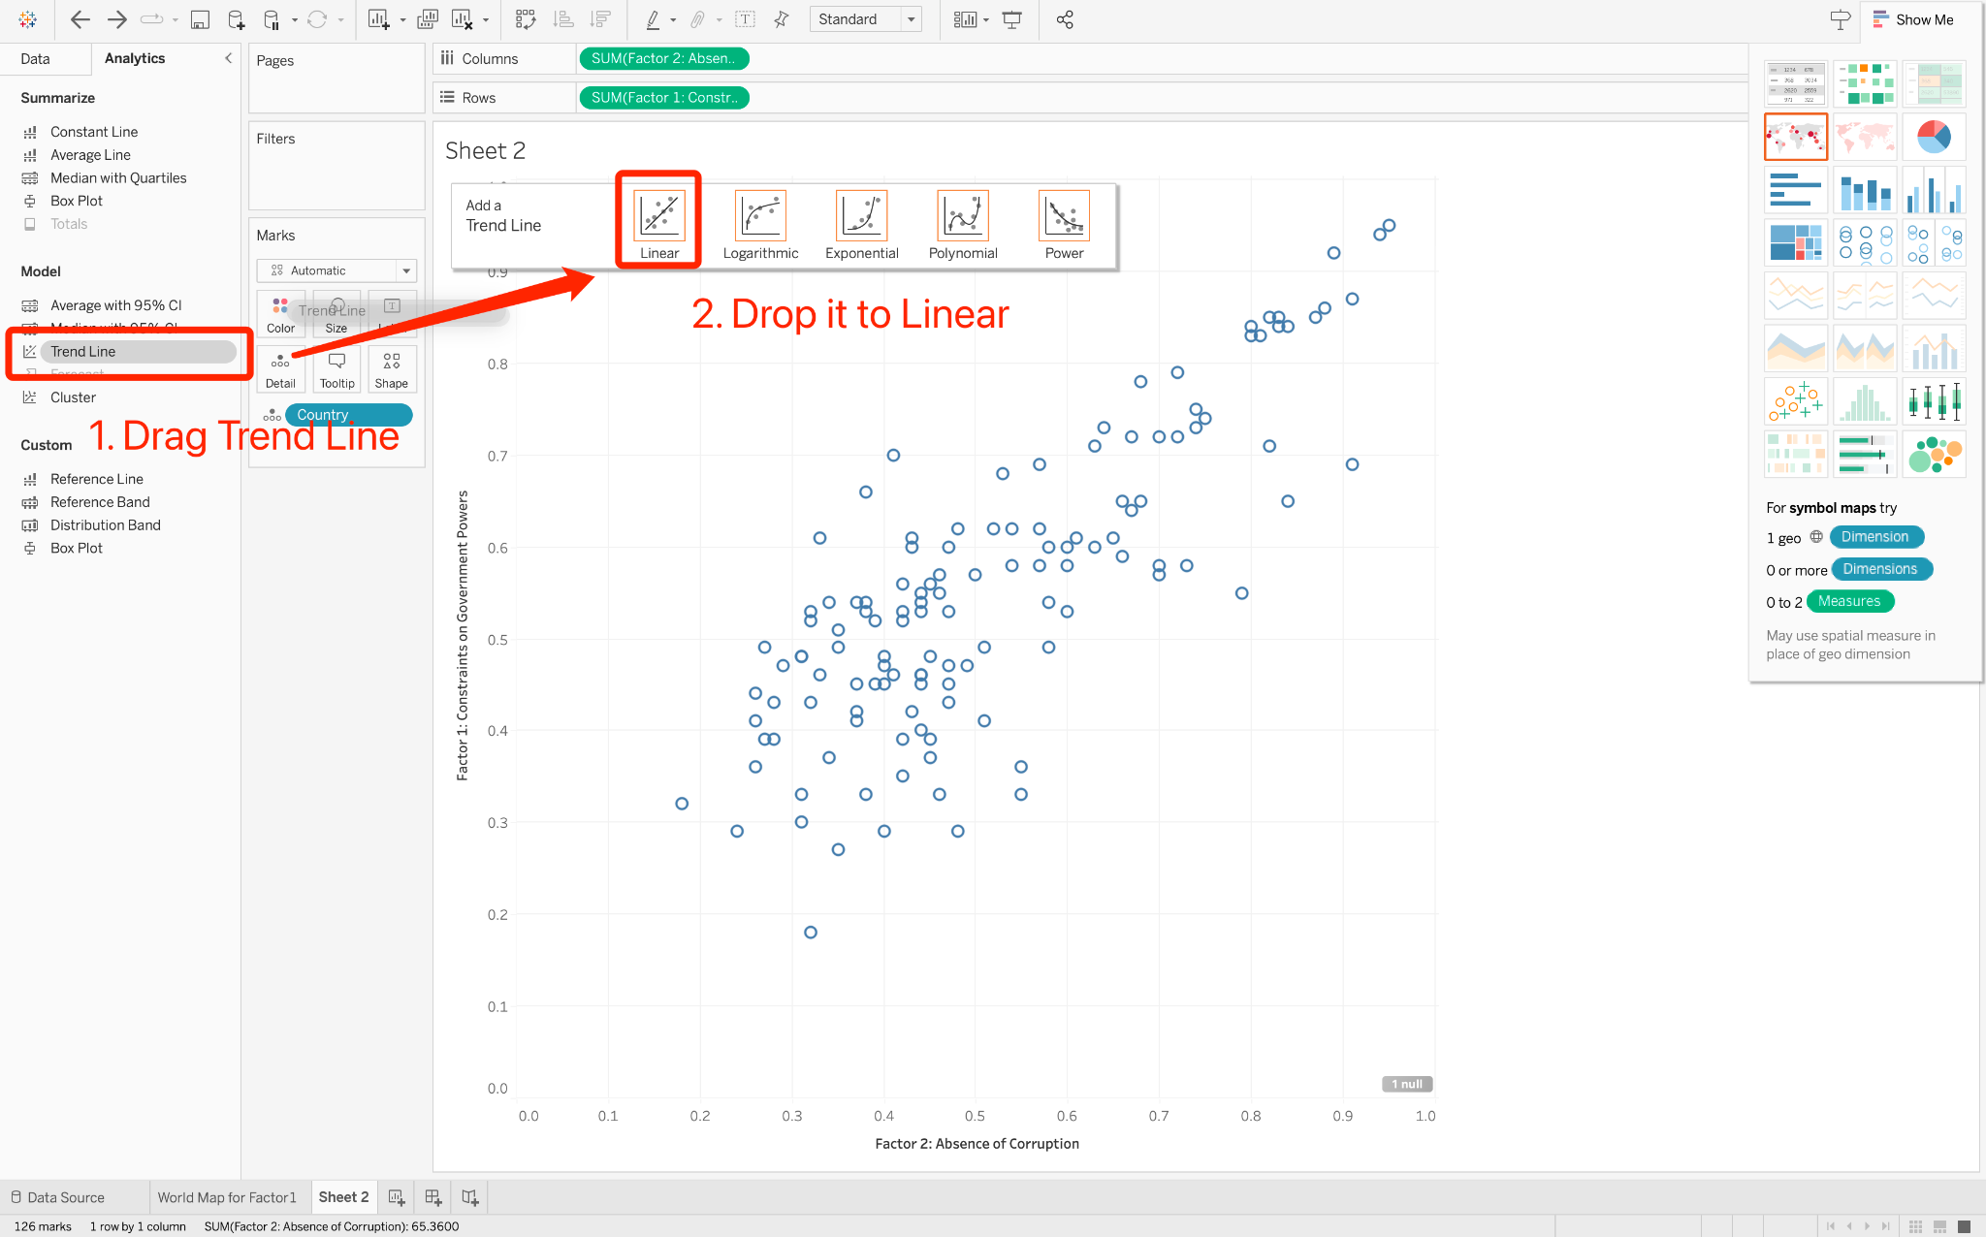

Hovering on the trend line, we can see the function fitted by Factor 1 and Factor 2.

### Show average values

Similarly, we can view the average of the data by dragging the "Average Line" from the Analytics pane and dropping it onto the "Table" option in the floating window.

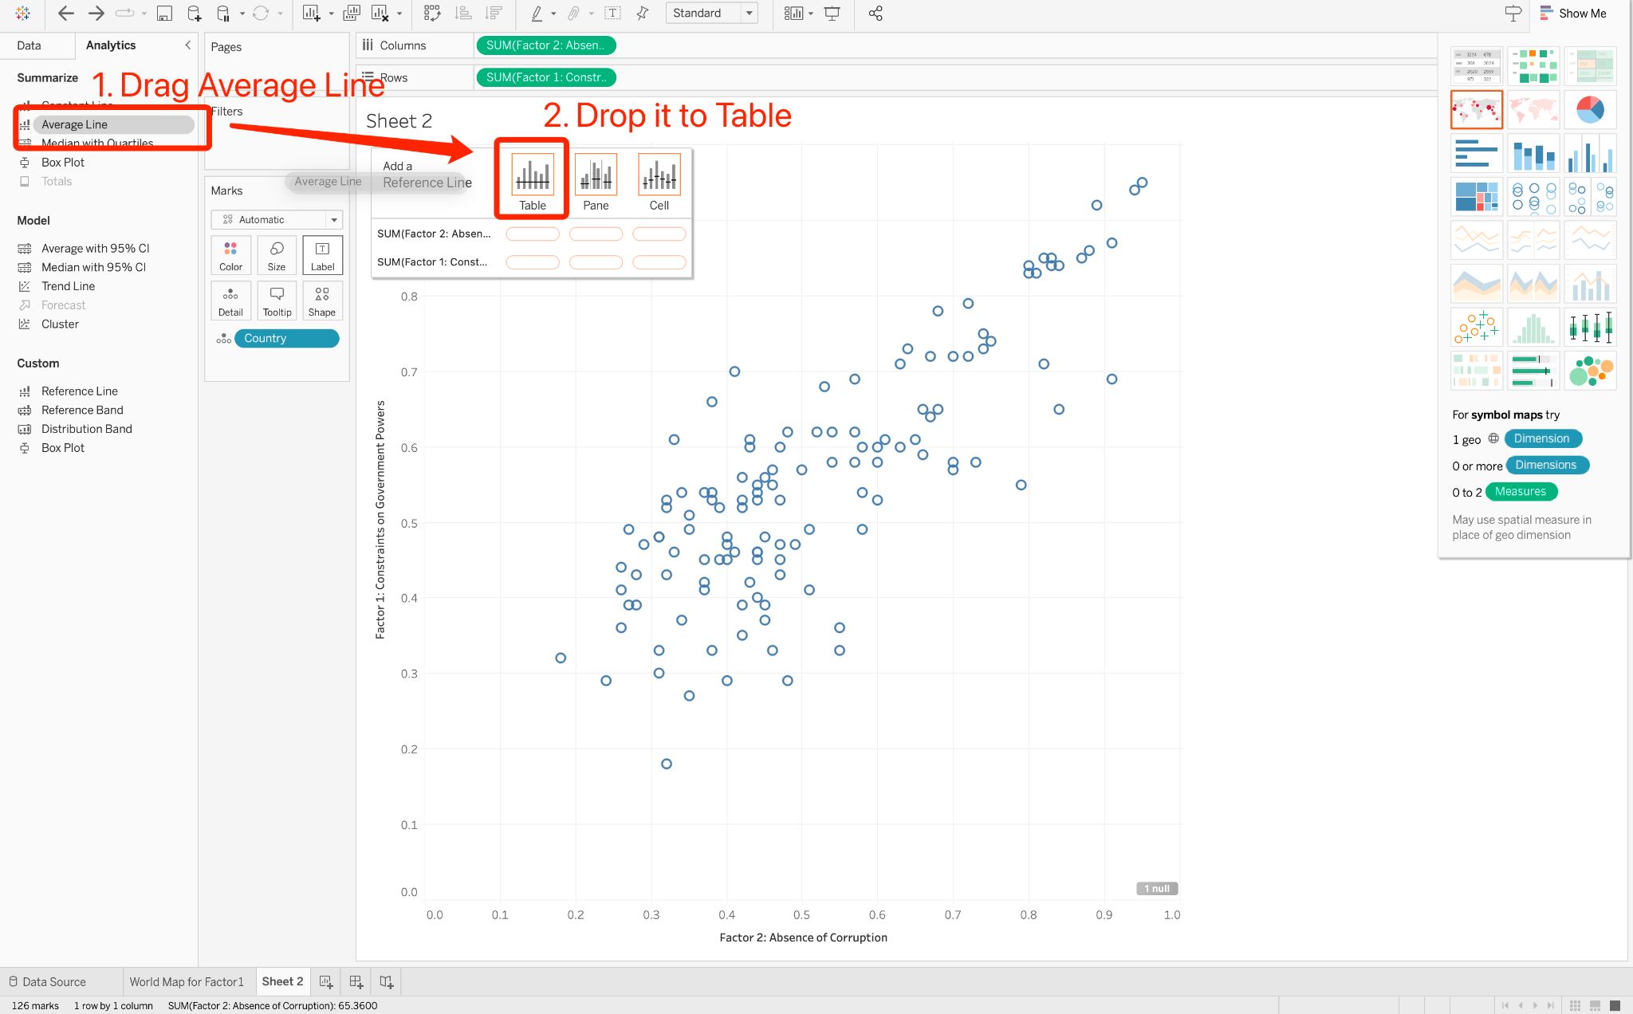

We can see that the countries falling in the first quadrant are above average in both Factor 1 and Factor 2.

### Add visual encodings

Just for exploratory purposes, we can also use the color of the points to represent Factor 3 and the size of the points to represent Factor 4.

1. Drag Factor 3 and drop it onto "Color" on the Marks card.
2. Drag 'Factor 4 and drop it onto "Size" on the Marks card.

### 

### Edit color palette

We want this dots to be orange:

1. Click on the "Color" button in the Marks card
2. Click "Edit Colors" and select the orange palette

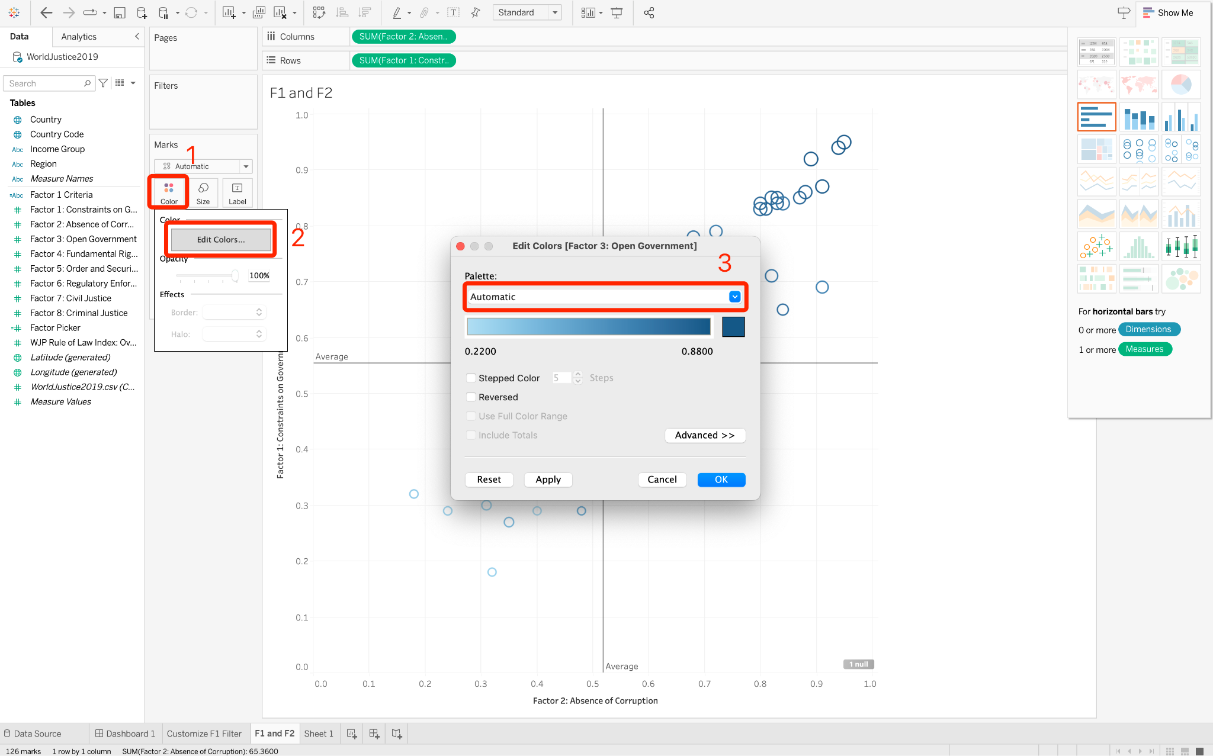

### Remove visual encodings

We do not want the visual encodings of Factor 3 and Factor 4, just drag them out of the Marks card.

### 

### Show/hide labels

Click the icon next to "Countries" on the Marks card and select "Labels" from the dropdown menu to display the labels for each country. If you wish to turn off the labels, you can click this icon again and select "Details."

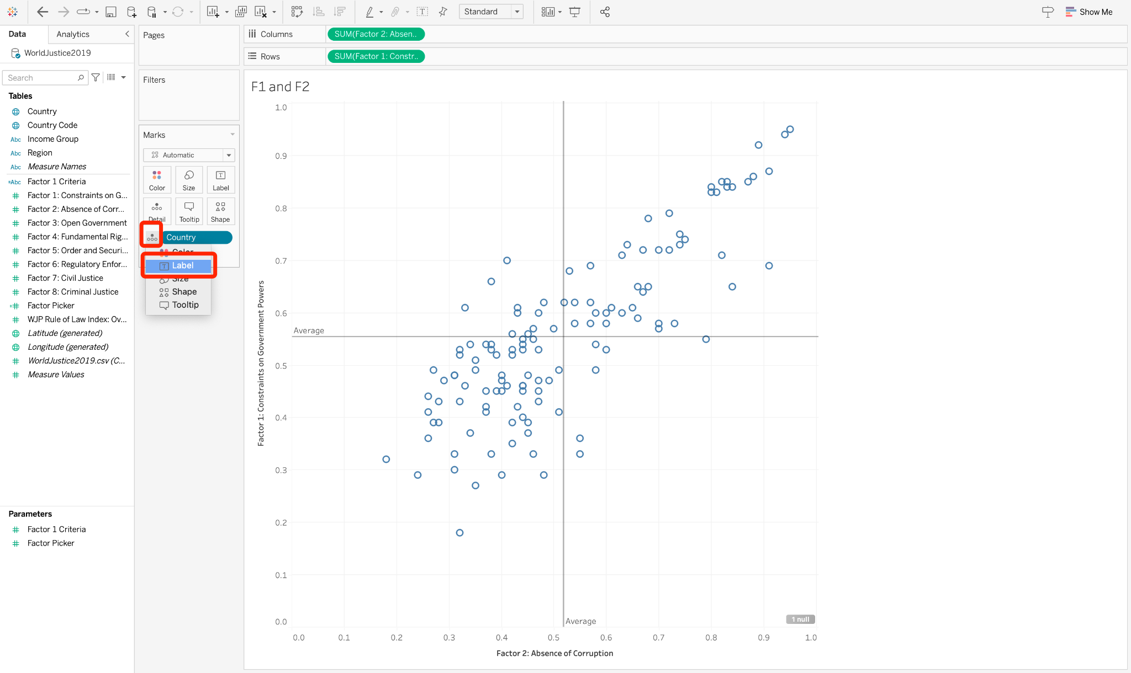

## 5. Add a filter to the view

Question to explore:

* Which countries are good in terms of Factor 1?
  + How can we filter countries with Factor 1 > 0.5?
  + How can we dynamically filter Factor 1?

### Sort bars

We first create a horizontal bar chart by dragging Factor 1 to the Columns shelf and Country to the Rows shelf.

We can sort the bars, to see which countries are above the threshold:

1. Hover over the top of the bars; an icon will appear.
2. Click this icon, and the bars will be sorted in descending order. Click it again, and the bars will be sorted in ascending order. Click it once more, and the bars will return to being unsorted. This process will cycle through these options.

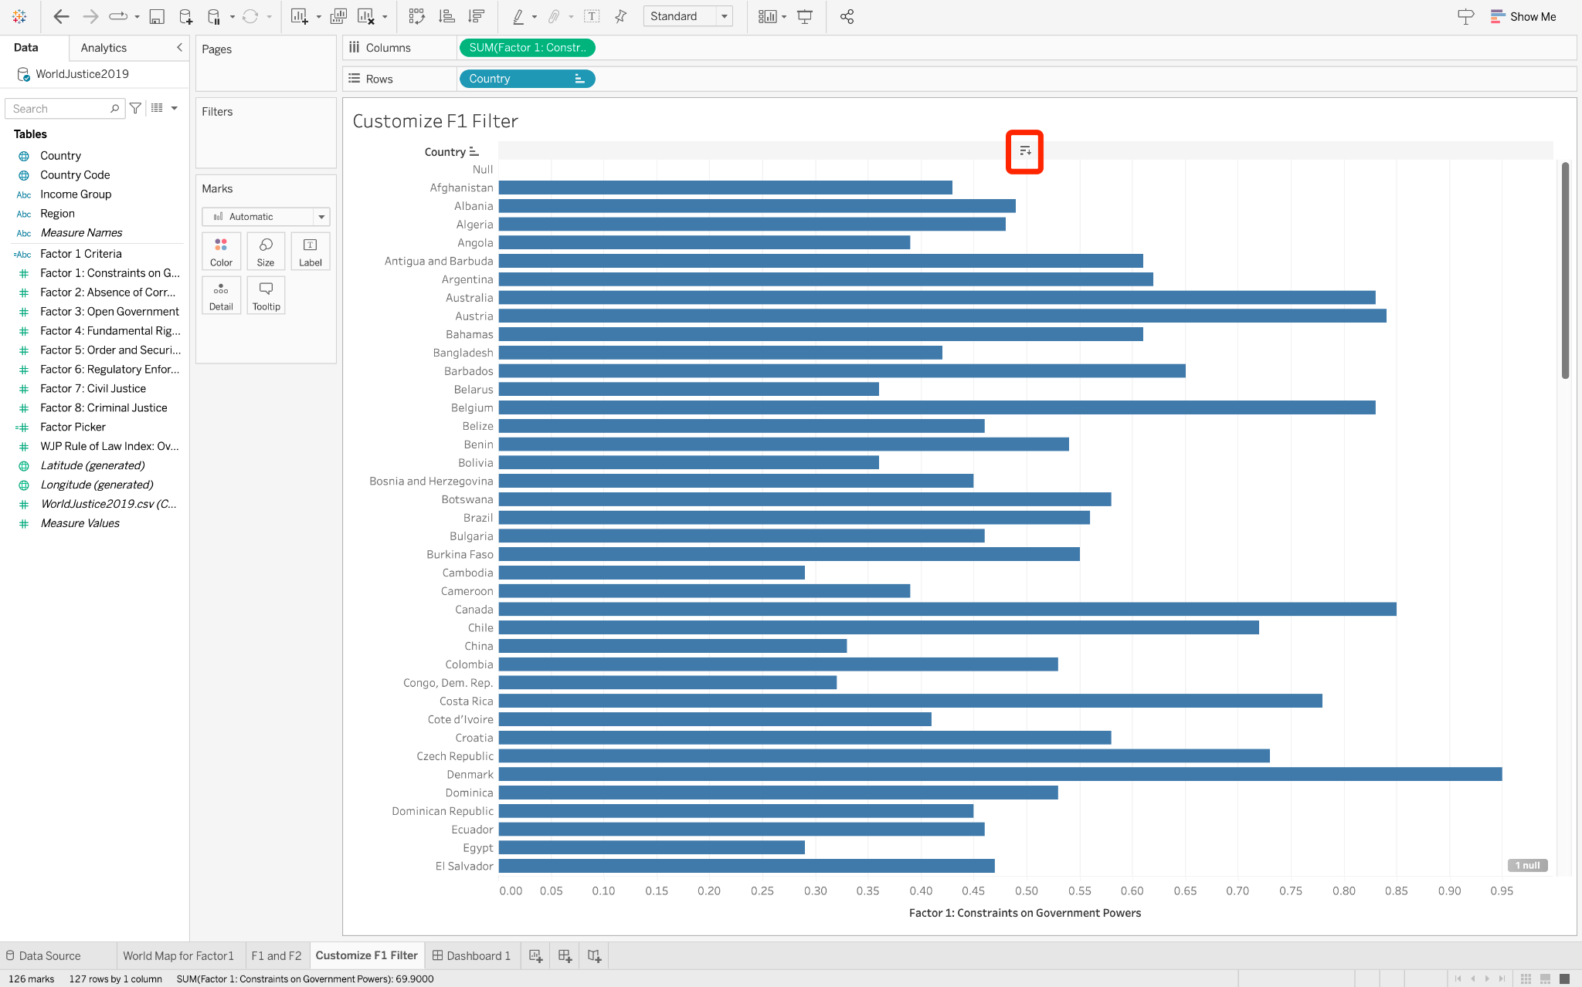

### Create a calculated field

Sometimes, our data source lacks a field (or column) necessary for our analysis. For instance, here we might need an additional field to indicate whether each country performs well concerning "Factor 1."

If a country's "Factor 1" value exceeds 0.5, we would label it as "good" in this context; if not, it is considered "not good." To address this, we can create a calculated field named "Factor 1 Criteria."

To create a calculated field:

1. Right click on the sidebar and click "Create Calculated Field."
2. Name it "Factor 1 Criteria"
3. Use the following scripts:

| IF [Factor 1: Constraints on Government Powers] > 0.5  THEN "Factor1 good"  ELSE "Factor1 not good"  END |
| --- |

If you want to know more about how to customize a calculated field, see [here](https://help.tableau.com/current/pro/desktop/en-us/calculations_calculatedfields.htm).

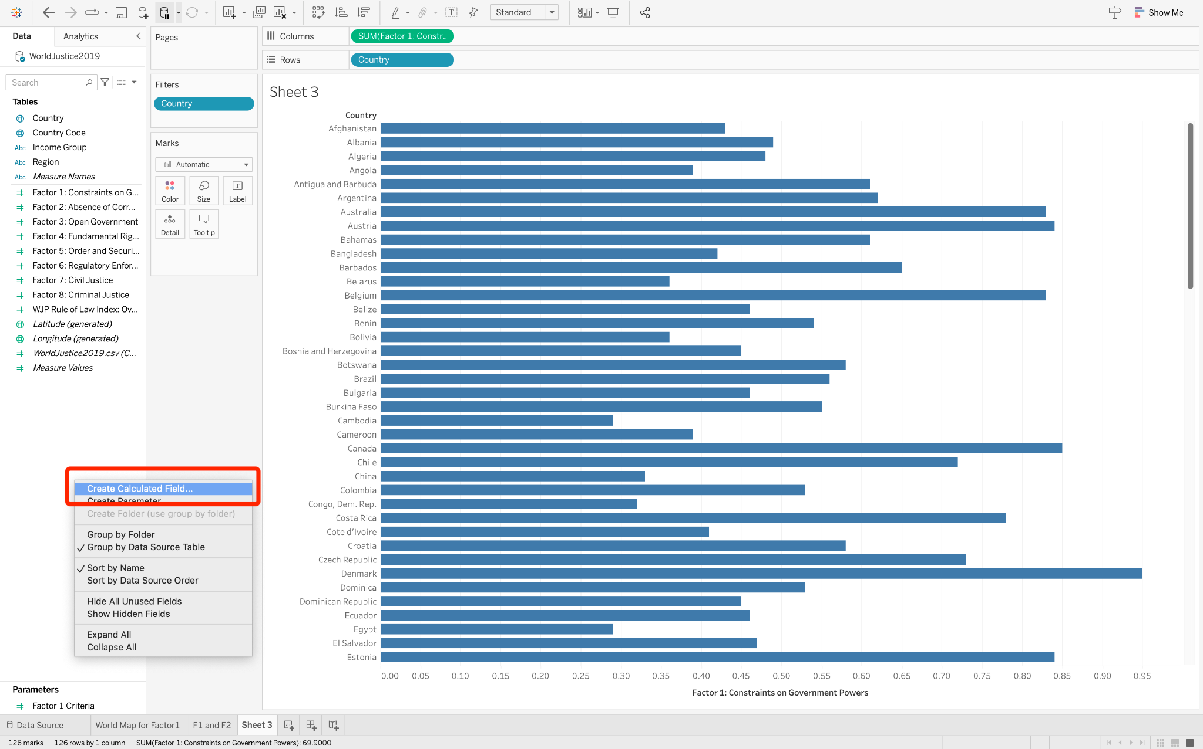

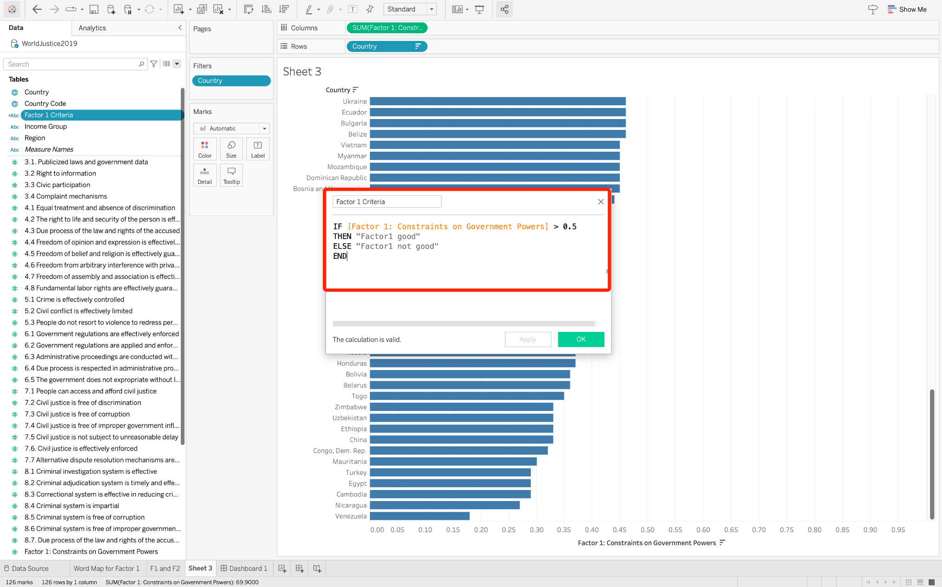

### Show filter

The calculated field "Factor 1 Criteria" we recently created will appear in the Data pane on the left sidebar.

To make this calculated field a filter:

1. Right-click on the Data pane and select "Show Filter"
2. The filter will then be displayed on the Filters card and the right sidebar.
3. We can filter data by checking or unchecking the checkboxes in the filter.

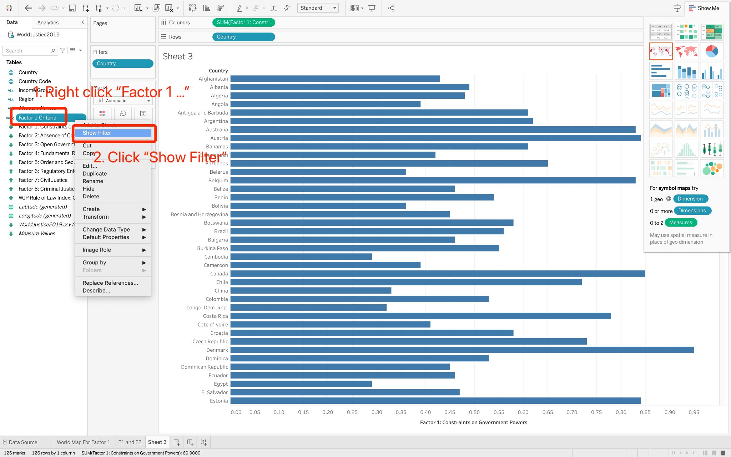

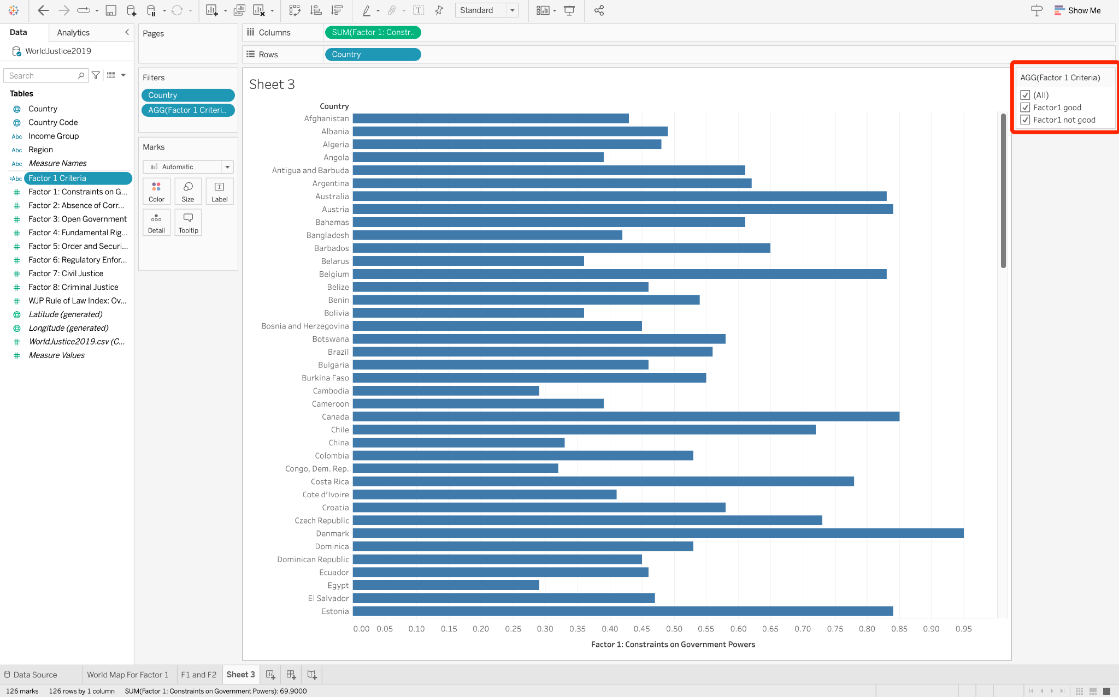

### Visualize a calculated field

We want to use the bars' color to indicate whether Factor 1 is good or not:

1. Select "All" on the filter
2. Drag the "Factor 1 Criteria" and drop it onto "Color" in the Marks card

Blue bars: Factor 1 is good.

Orange bars: Factor 1 is not good.

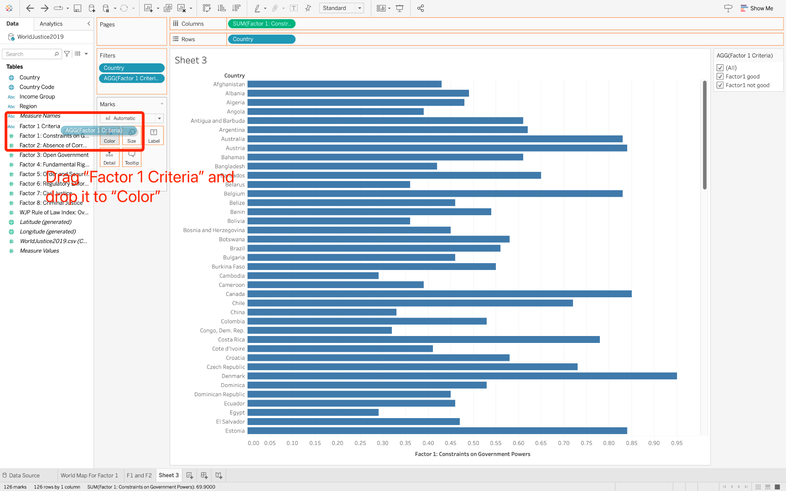

### Create a parameter (dynamic threshold)

Next, we will learn how to dynamically filter Factor 1 by replacing 0.5 with a dynamic threshold.

This threshold must be within Factor 1's range, not less than its minimum and not exceeding its maximum. Therefore, we need to create a parameter that captures the range of Factor 1.

A parameter is a workbook variable such as a number, date, or string that can replace a constant value.

To create a parameter "Factor 1 Criteria":

1. Right-click on the Data pane on the left sidebar and select "Create Parameter."
2. We need to specify how the parameter accepts values. Select "Range" for "Allowable values," and set the Minimum and Maximum values.
3. We use "Add values from" to set the Minimum and Maximum values: choose Factor 1 from the dropdown box to import values directly from Factor 1.

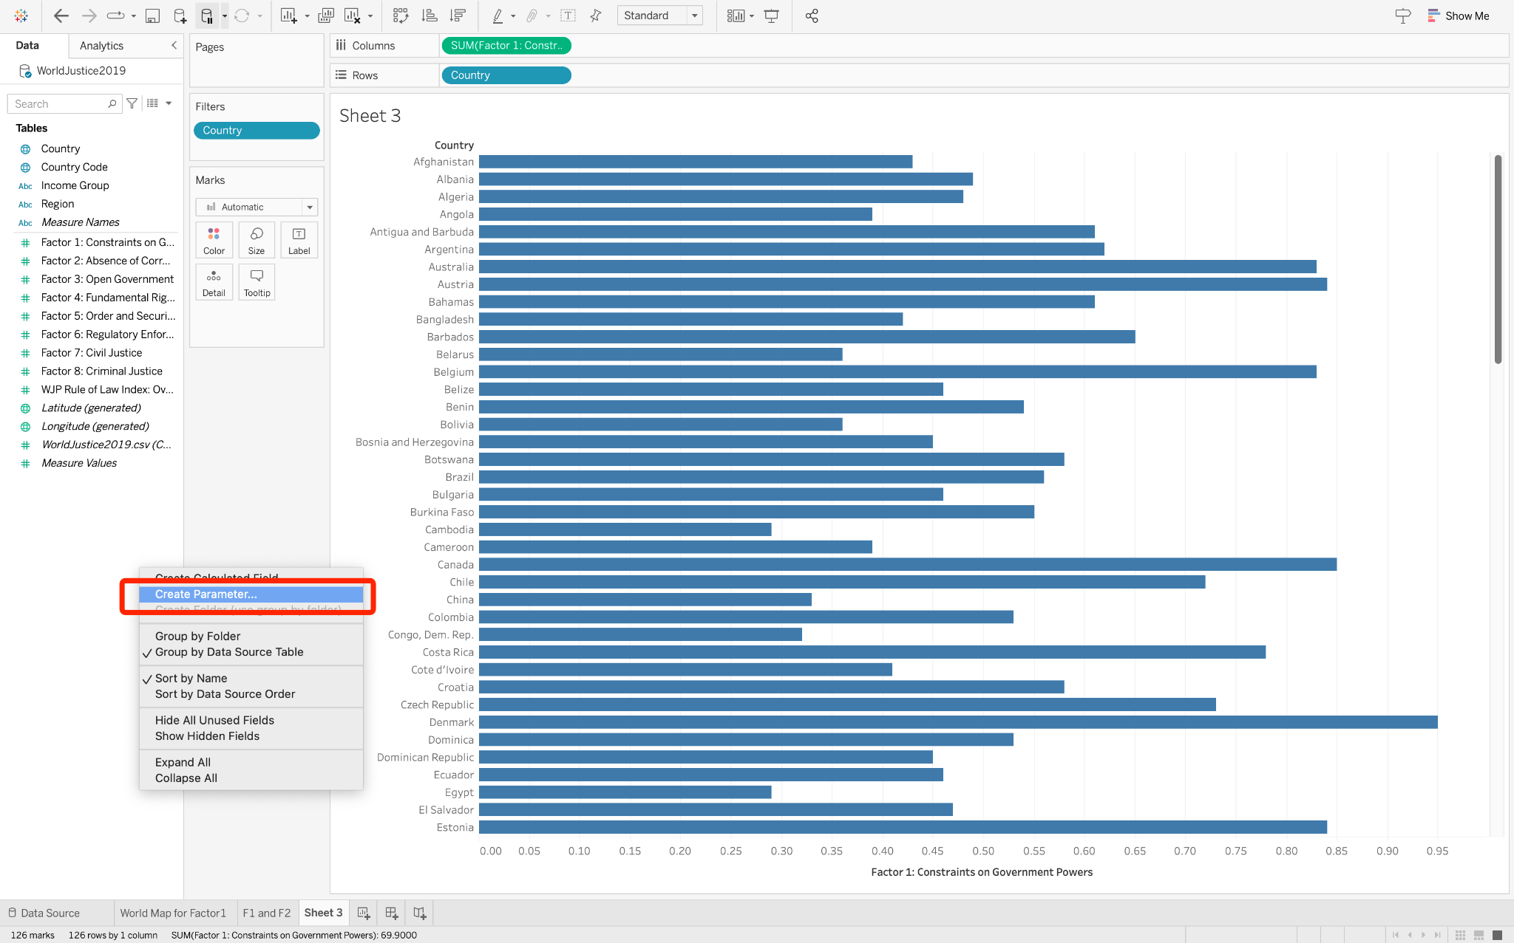

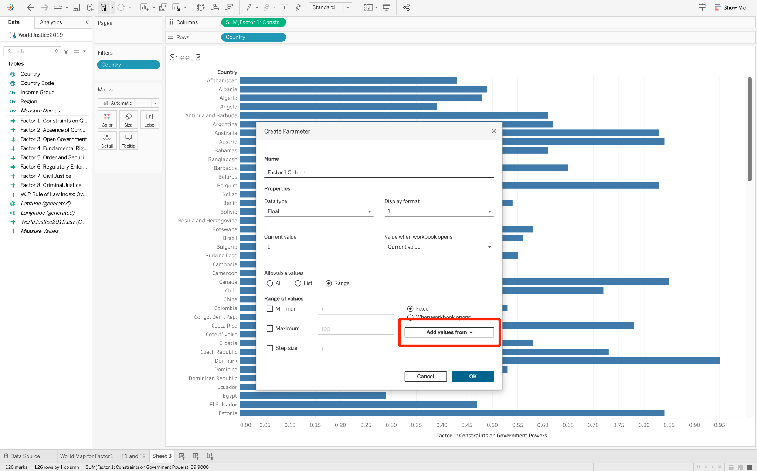

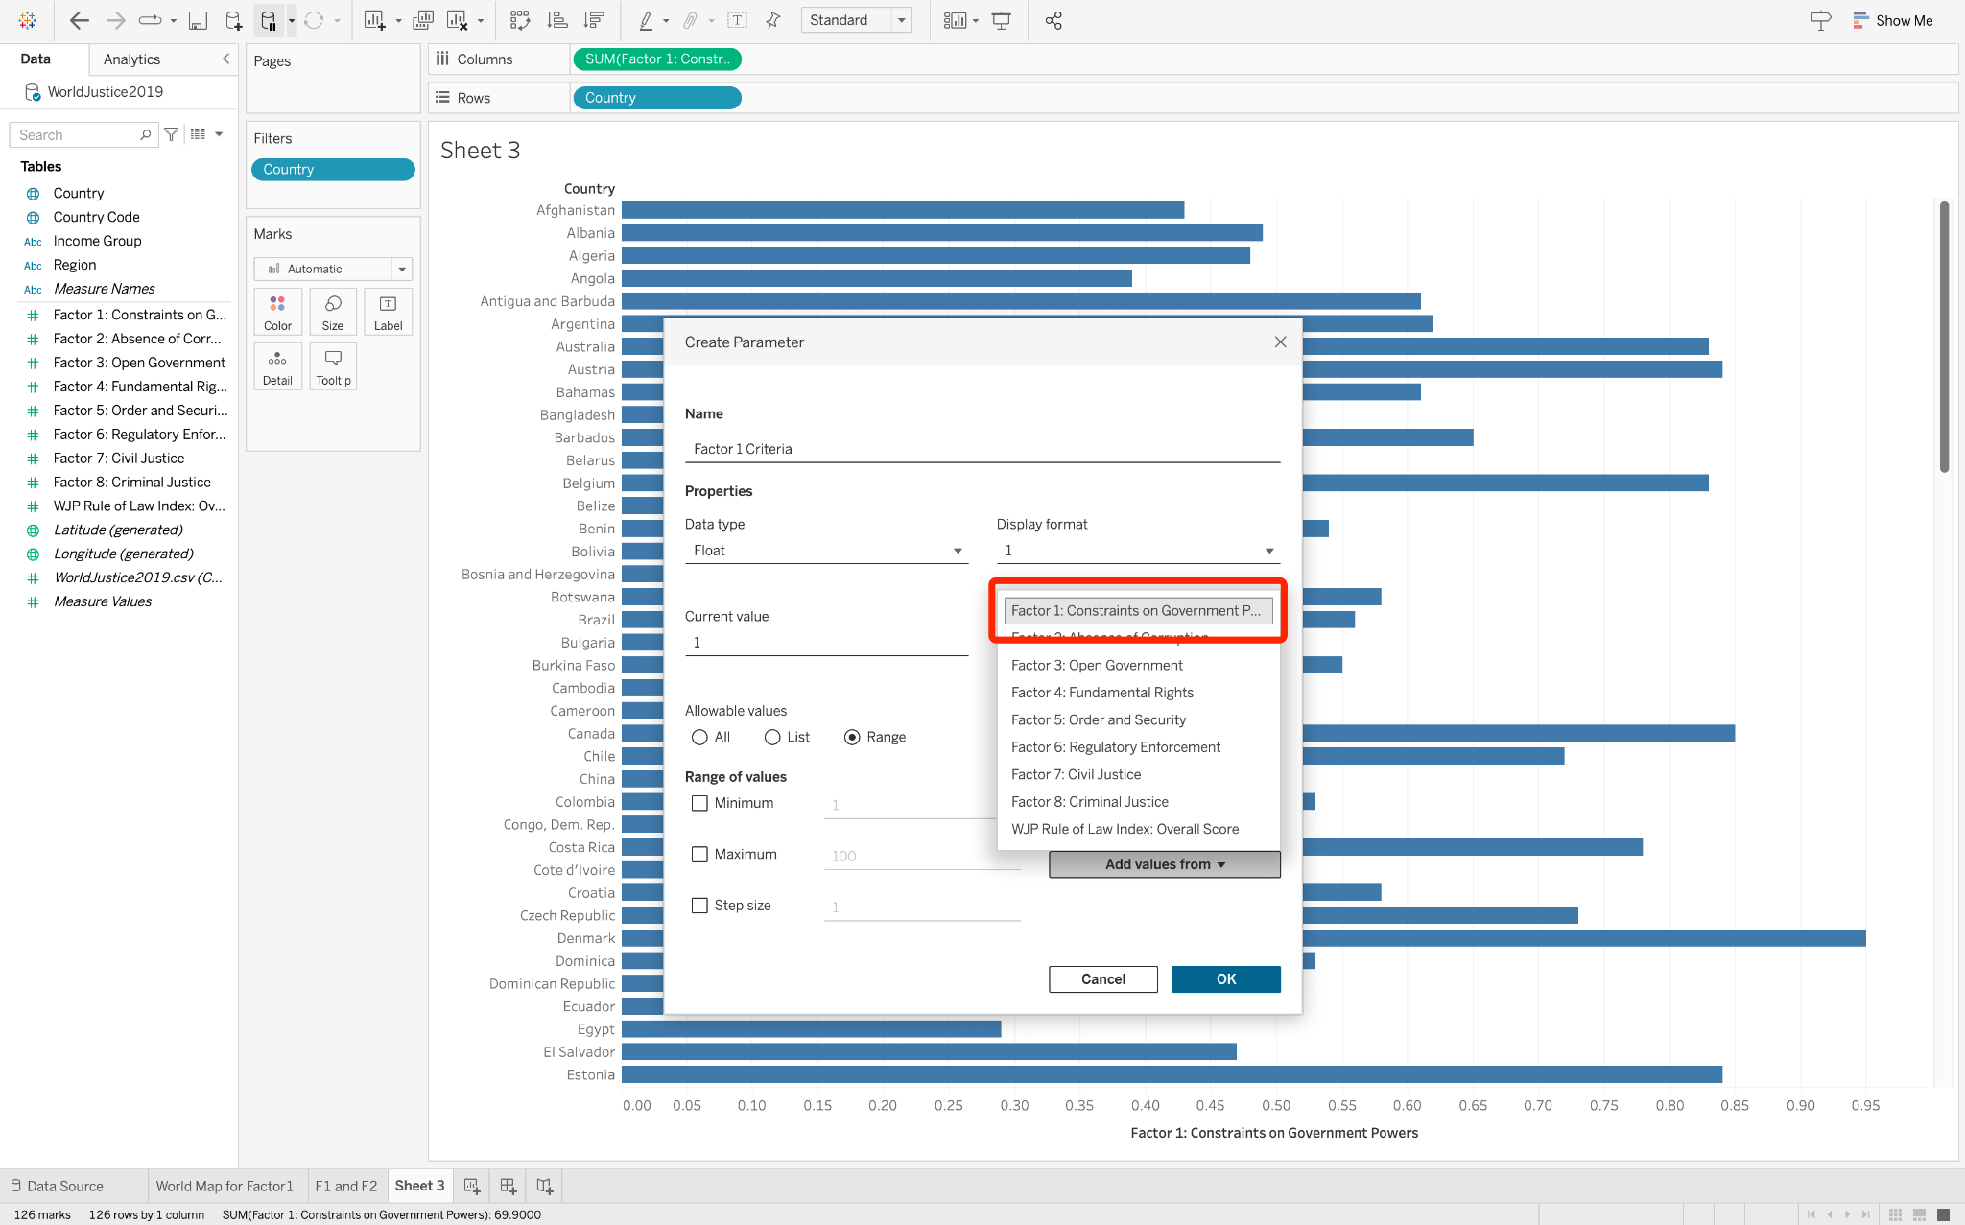

### Edit the filter

To edit the filter

1. Right-click on the "Factor 1 Criteria" field, and select "Edit"
2. Delete 0.5, drag "Factor 1 Criteria" from "Parameters" and drop it into the place where 0.5 was.

The scripts should be like:

| IF [Factor 1: Constraints on Government Powers] > [Parameters].[Factor 1 Criteria]  THEN "Factor1 good"  ELSE "Factor1 not good"  END |
| --- |

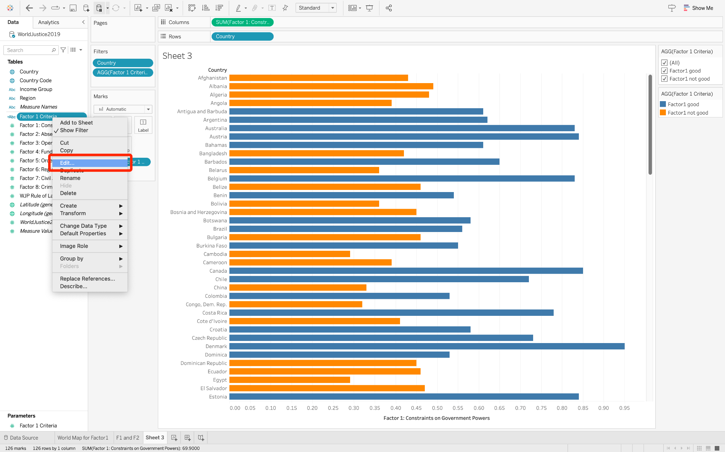

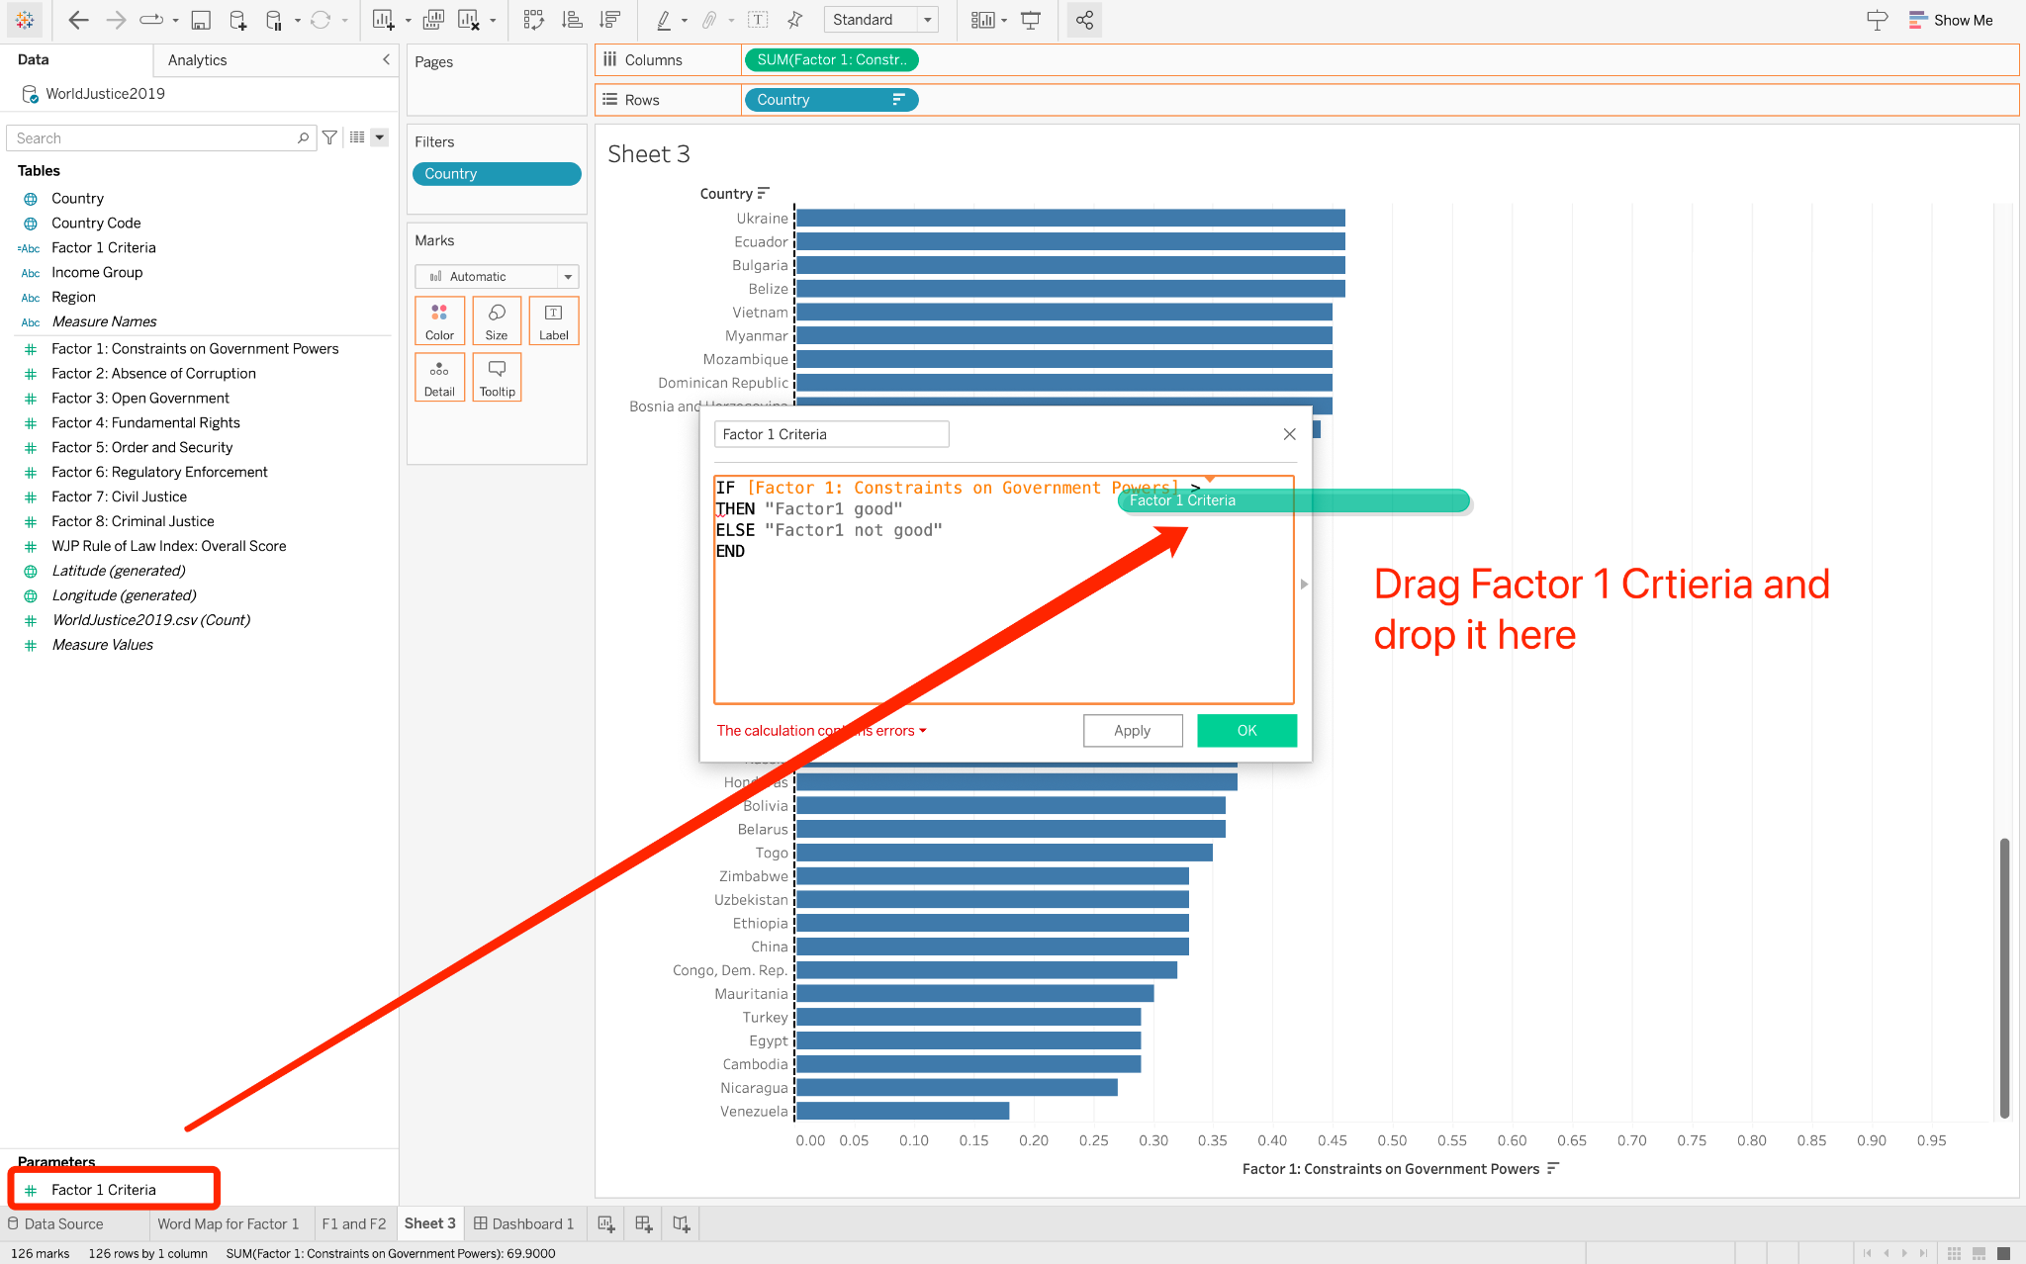

### Show parameter

1. Right-click on the "Factor 1 Criteria" parameter and select "Show Parameter."
2. The "Factor 1 Criteria" will appear as a slider on the right sidebar. By dragging this slider, we can dynamically adjust the criteria and filter Factor 1.

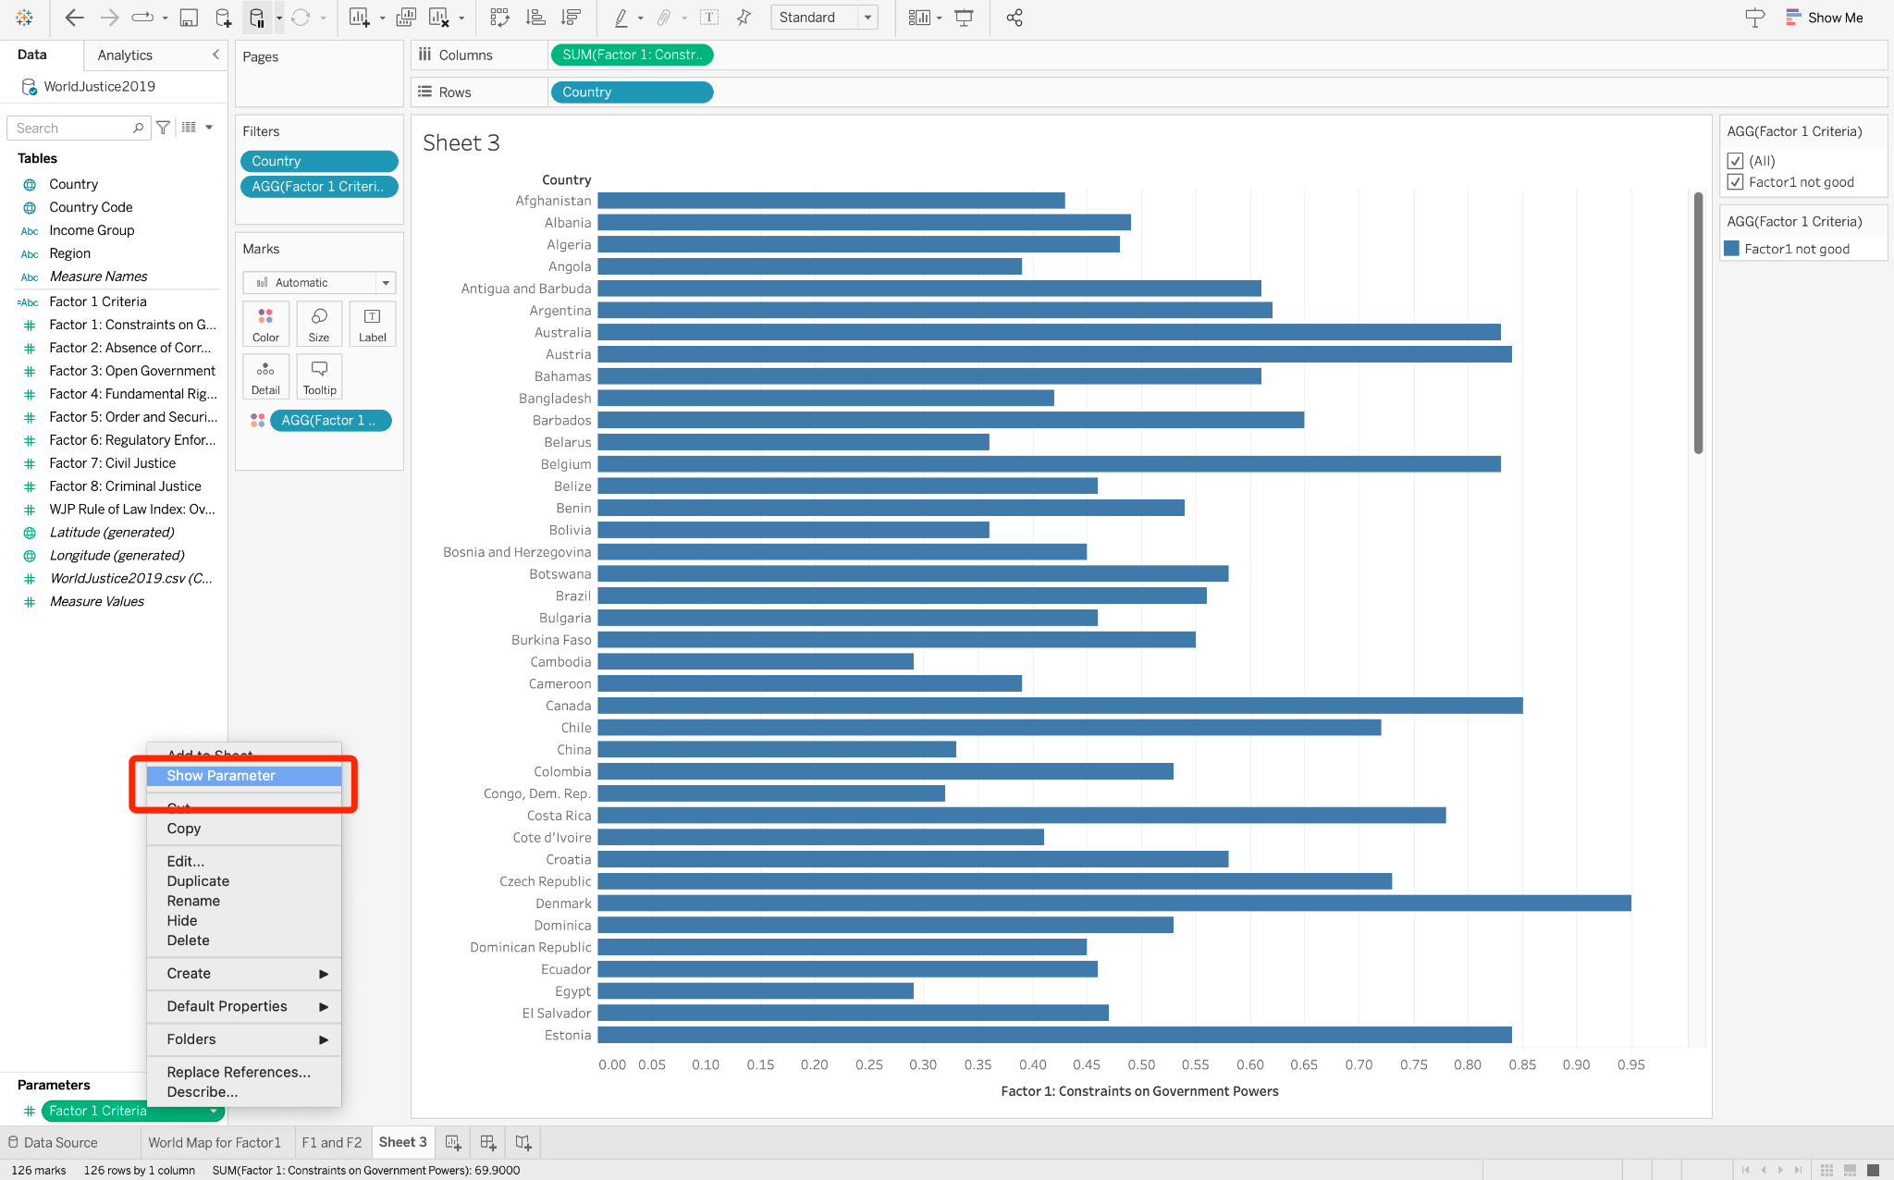

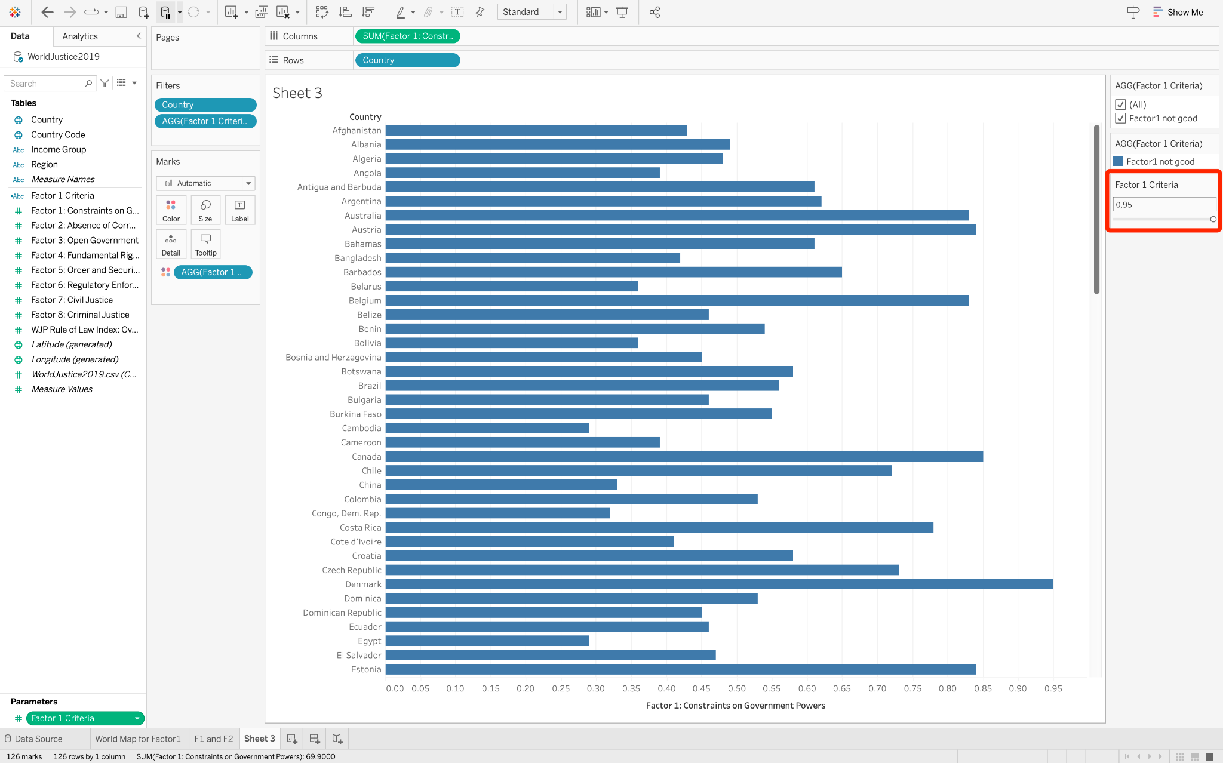

## 6 Create a dashboard

We can create a dashboard to show all charts we create before together.

1. Create a new dashboard from sheet tab bar
2. Drag Sheets and drop them to the dashboard
3. Adjust the size and position of each sheet

